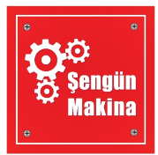

MODEL
SM-300 SINGLE , SM-450 SINGLE , SM-600 SINGLE
DOUGH ROLLING MACHINE (SINGLE ROLLER)

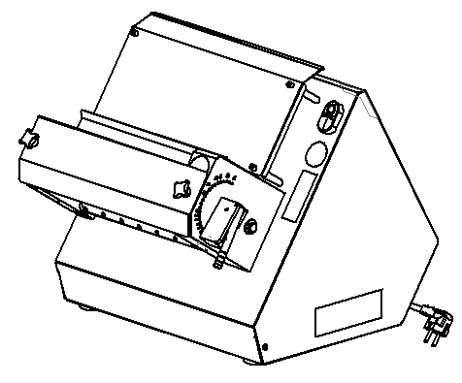

USER & MAINTENANCE MANUAL

ÜRETİCİ FİRMA: ŞENGÜN MAKİNA İNŞAAT ve KIRTASİYE SAN. TİC. LTD. ŞTİ

WARRANTY CERTIFICATE
SERIAL NUMBER:
SALE DATE:
Sold at the above date SM-…….. SINGLE MODEL DOUGH ROLLING MACHINE is guaranteed against production failures for 1 Year by ŞENGÜN MAKİNA İNŞAAT ve KIRTASİYE SAN. TİC. LTD. ŞTİ.

Warranty Terms;
- Warranty terms start after the product delivery for 1 year.
- Recommended daily working time is 10 hours. The scope of warranty is assessed by year or by working hours.
- The product is under warranty except plastic rollers (included plastic rollers if it is a manufacturing defect).
- Documents are invalid, if haven’t sale date and confirm signature of company. You have to show the warranty certificate to benefit from the warranty.
- Device is guaranteed against defects if mount and use as described ın the use and maintenance manual.
- Detection the location of defects, and elimination of the problems are responsibilities of the ŞENGÜN MAKİNA…
- Warranty terms includes only one device. You can’t claim any rights or compensation for another devices.
- If Changes are made at the type, model and serial numbers, the warranty eliminates.
- If material, worker or assembly defects appear, repaired free by ŞENGÜN MAKİNA at the product warranty period (Transportation cost is not included).
- Failures are only repaired by ŞENGÜN MAKİNA’s personal. The intervention of unauthorized person, cancel the appliance of warranty.
- Installation have to be done by ŞENGÜN MAKİNA’s personal. İf usage place changes, customer must give information to ŞENGÜN MAKİNA
- In the event of failure service must be informed.
- The failures and damages given by external factors are out of the warranty terms.
- Any failure of the product warranty period is added to the product warranty time. The repair time is until 20 working days.

AUTHORIZED PERSON
STAMP –SIGNATURE

CONTENTS

SECTION 1: INTRODUCTION

  - General Introduction of Dough Rolling Machine
  - Technical Specifications Table

  - Safety Warnings Labels

SECTION 2: INTRODUCTION OF MACHINE BODY COMPONENTS

2.1 Guard Sheet Assembly

2.2 Body Components

SECTION 3: INSTRUCTIONS FOR USE

3.1 Usage Recommendations

3.2 Safety Warnings

3.3 Operating and Starting Instructions

SECTION 4: MAINTENANCE

4.1 Exterior Body Maintenance

4.2 Scraping Knife Maintenance

SECTION 5: ELECTRICAL DİAGRAM

SECTION 1: INTRODUCTION
  - General Introduction Of Dough Rolling Machine Model
Uses at lahmacun, pizza and other dough rolling processes. Dough thickness and diameter get easy with roller gap adjustment system. SM-300 SINGLE Dough rolling process perform in min. 3, max. 5 seconds, SM-450 SINGLE and SM-600 SINGLE min. 6, max. 8 seconds with fast and easy using feature.

  - Technical Specifications Table

Technical Specifications | SM-300 SINGLE | SM-450 SINGLE | SM-600 SINGLE
Machine Length (cm) | 54 | 54 | 54
Machine Width (cm) | 44 | 59 | 74
Machine Height (cm) | 44 | 44 | 44
Machine Weight (Kg) | 34 | 40 | 47
Engine Power (kW) | 0.37 | 0.37 | 0.37
Electrical Connection (V-HZ) | 230V 1N 50/60HZ | 230V 1N 50/60HZ | 230V 1N 50/60HZ
Max. Dough Weight (gr) | 1500 | 2000 | 2500
Dough Diameter (cm) | 19-29 | 19-45 | 19-60
Roller Range (mm) | 0-10 | 0-10 | 0-10
Hourly Production Quantity | 720-1200 | 450-600 | 450-600

1.3 Safety Warnings Labels

LABELS

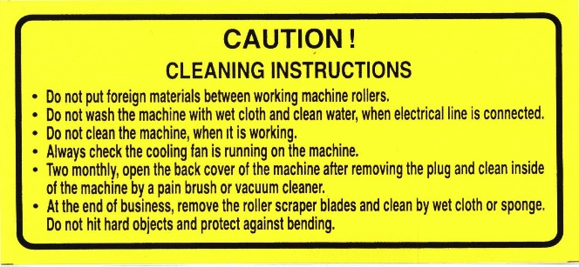
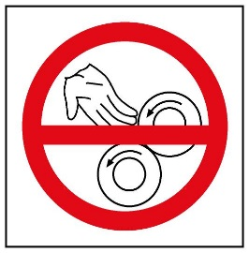

SECTION 2: INTRODUCTION OF MACHINE BODY COMPONENTS

2.1 Guard Sheet Assembly

- THIMBLE
- GUARD SHEET
- BAKELITE
- STAY BOLT
- STAY BOLT
- TRANSPARENT PROTECTION APPARATUS (OPTIONAL)

2.2 Body Components
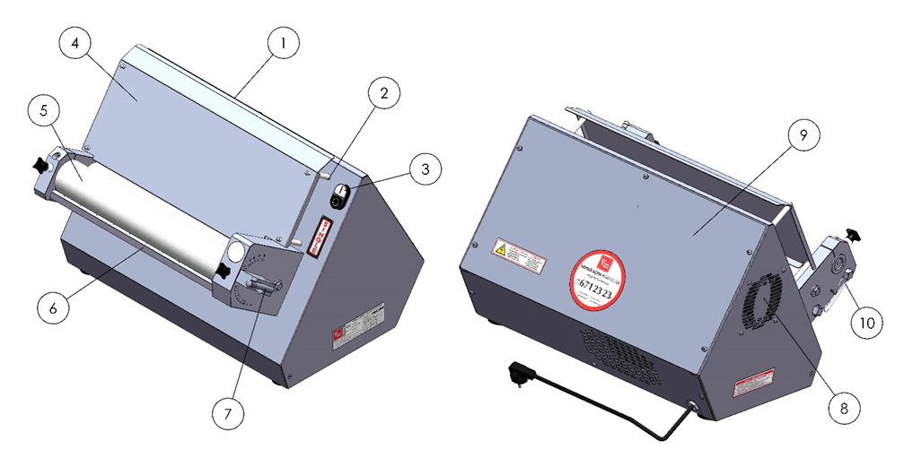

FRONT VIEW BACK VIEW

1 – BODY 6 – ROLLER SCRAPER
2 – SHEET HOLDER PIN 7 – ADJUST HANDLE
3 – START/STOP SWITCH 8 – FAN
4 – CENTRAL SHEET 9 – BACK COVER
5 – ROLLER GROUP 10 –SCRAPERS WIRE

SECTION 3 INSTRUCTIONS FOR USE

3.1 Usage Recommendations

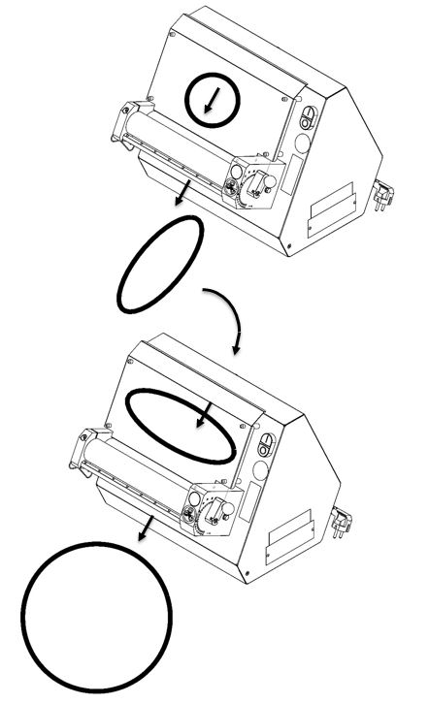

For rolling circular dough (lahmacun dough etc.);

- Compress the dough and make it circular.
- Pass through the dough to the upper roller gap.
- Rotate the dough (shown in figure) then pass through the dough in parallel to the bottom roller gap.

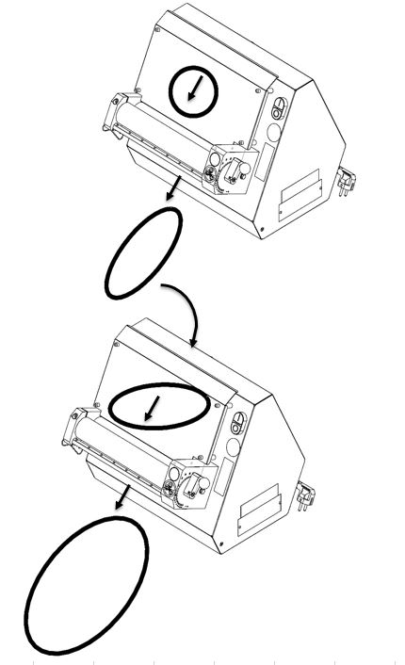

For rolling ellipse dough (pide dough);

- Compress the dough and make it circular.
- Pass through the dough to the upper roller gap.

Rotate the dough (shown in figure) then pass through the dough in 45° to the bottom roller gap.

3.2 Safety Warnings

- Secure voltage is between 230 V and 240 V
- Set up on a straight floor.
- Single phase on operating.
- Don’t wipe the machine with a wet cloth when connect to plug.
- Cut electric current before opening protection system.
- Check the air intake of the cooling fan daily.

3.3 Operating and Starting Instructions

- Connect to monophase electrical supply.
- Push the “I” button.
- Adjust the roller space shown in picture.(This procedure adjust the dough thickness and diameter)
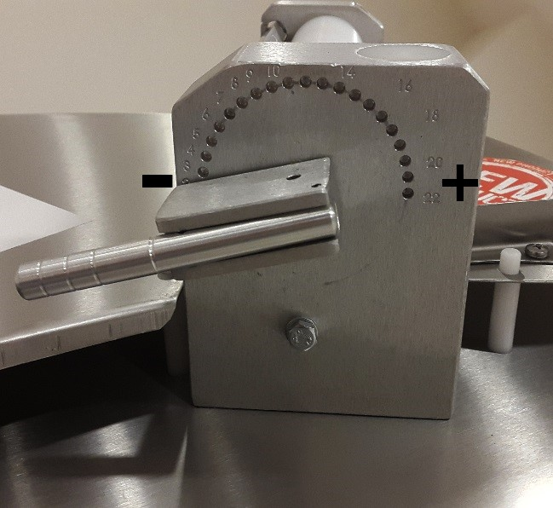

Adjust the dough thickness from “0” to “22” shown in figure.

- Pull the adjust handle and rotate the “+” or “-” direction.
- Rotate the knob to “+” direction for enlarge the dough thickness. Rotate the knob to “-” direction for reduce the dough thickness.
- Push the adjust handle knob when the intended roller gap adjusted.

DESIRED PRODUCT | UPPER | BOTTOM
LAHMACUN
PIDE
PİZZA
TORTILLA BREAD
BOREK DOUGH

NOTE = Entrance roller gap advice to be bigger than the exit roller gap.

NOTE: Scrapers must be stretched

SECTION 4 MAINTENANCE

4.1 Exterior Body Maintenance
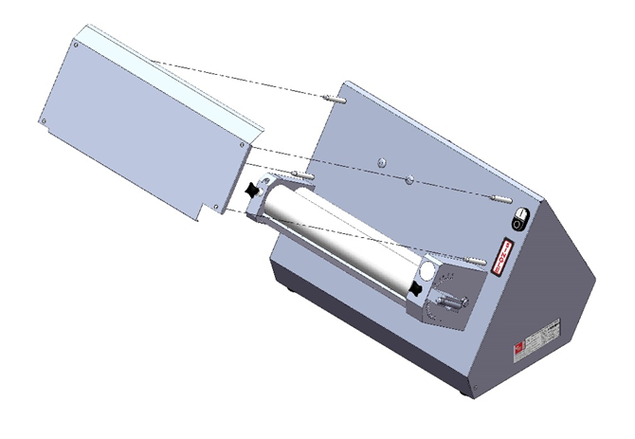
Pull up the central sheet shown in picture then clean the flour and crumbs. Stop the machine and unplug the electrical supply then clean with wet cloth. Don’t plug the electrical supply before the machine dry.

4.2 Scrapers Maintenance
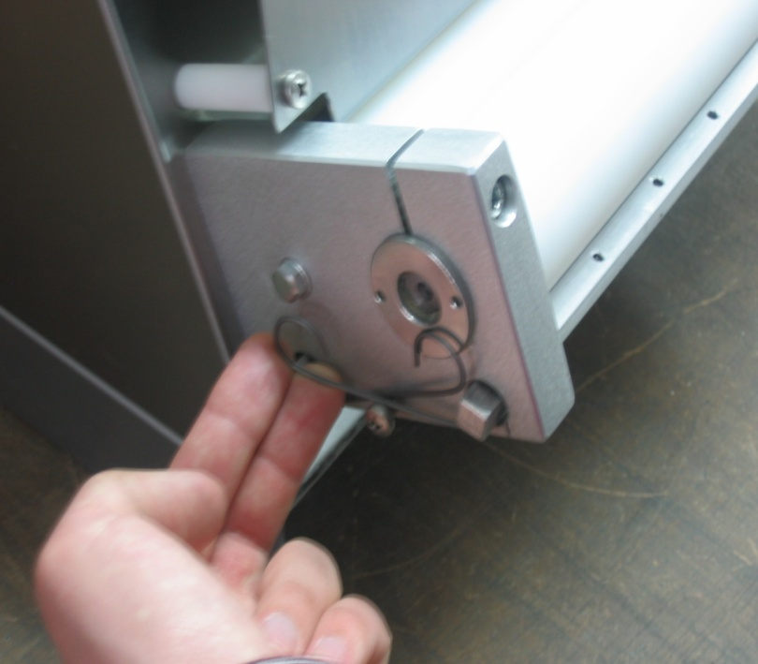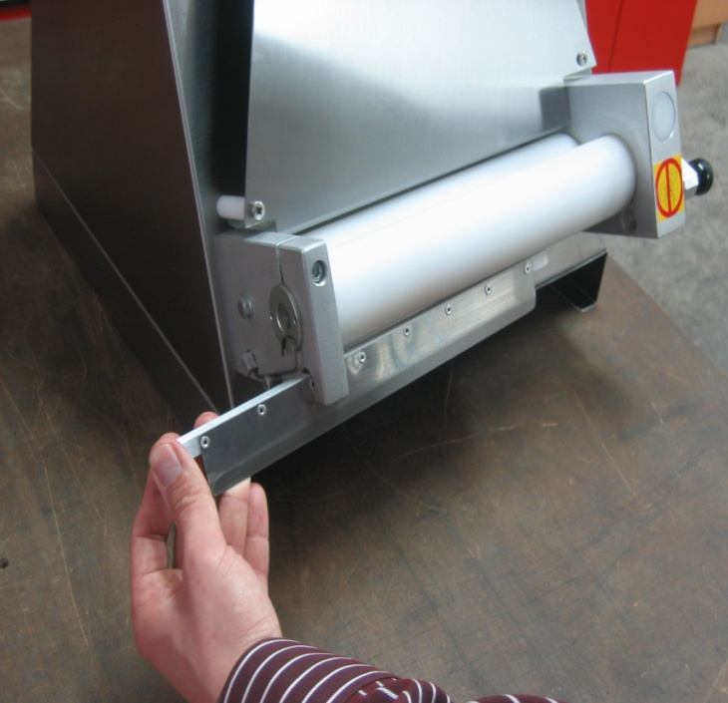

- Push up scrapers wire as shown in the figure
- Remove the scrapers from the hole as shown in the figure and clean the scrapers daily.

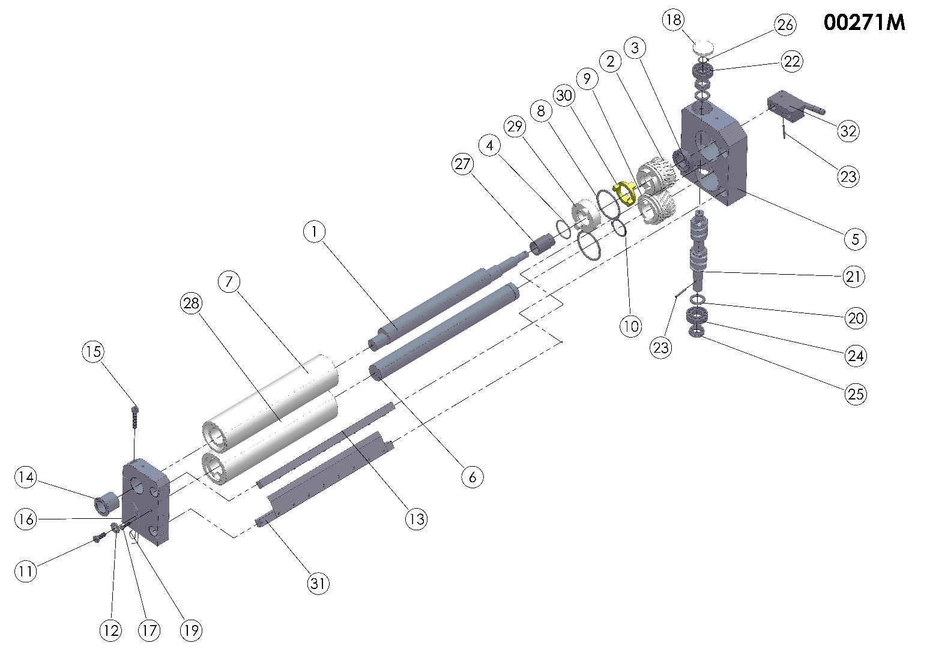
SECTION 5: SPARE PARTS MANUAL

00271M (ROLLER GROUP) SPARE PARTS LIST
ITEM NO. | SPARE PART NUMBER | DESCRIPTION OF THE SPARE PART | UNIT |  | ITEM NO. | SPARE PART NUMBER | DESCRIPTION OF THE SPARE PART | UNIT
1 | 00240 | ROLLER CAMSHAFT(TOP) | 1 |  | 17 | 00047 | BOLT | 1
2 | 00204 | GEAR | 1 |  | 18 | 00219 | COVER | 1
3 | 00208 | BEARING | 1 |  | 19 | 00267 | SCRAPER SPRING | 2
4 | 00226 | O-RİNG | 1 |  | 20 | 00555 | WASHER | 1
5 | 00201 | GEAR BOX | 1 |  | 21 | 00206 | WORM GEAR | 1
6 | 00245 | ROLLER SHAFT(TOP) | 1 |  | 22 | 00209 | BEARING | 1
7 | 00261 | TOP ROLLER | 1 |  | 23 | 00096 | PIN | 2
8 | 00228 | SHIFT SEGMENT | 2 |  | 24 | 00207 | BEARING | 1
9 | 00205 | GEAR | 1 |  | 25 | 00565 | THIMBLE | 2
10 | 00249 | SEGMENT | 1 |  | 26 | 00211 | SEGMENT | 1
11 | 00043 | BOLT | 2 |  | 27 | 00570 | THIMBLE | 1
12 | 00044 | WASHER | 2 |  | 28 | 00256 | TOP ROLLER (BOTTOM) | 1
13 | 00352M | TOP ROLLER SCRAPER (BOTTOM) | 1 |  | 29 | 00227 | ROLLER BREAK COUPLER | 1
14 | 00222 | THIMBLE | 1 |  | 30 | 00218 | ROLLER BREAK COUPLER | 1
15 | 00349 | BOLT | 1 |  | 31 | 00352M | TOP ROLLER SCRAPER(BOTTOM) | 1
16 | 00574 | ROLL BEARING | 1 |  | 32 | 00263M | CONTROL LEVER GROUP | 1

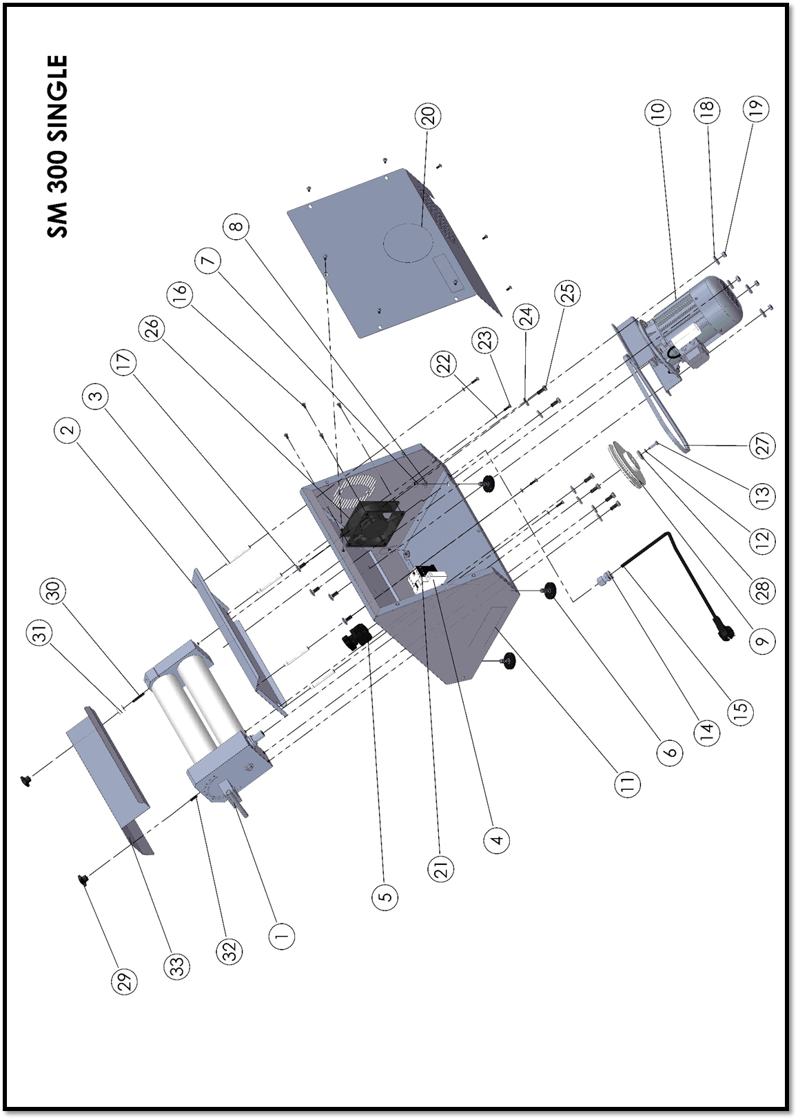
SM-300 SINGLE

SM-300 SINGLE BODY SPARE PART LIST

ITEM NO. | SPARE PART NUMBER | DESCRIPTION OF THE SPARE PART | UNIT |  | ITEM NO. | SPARE PART NUMBER | DESCRIPTION OF THE SPARE PART | UNIT
1 | 00271M | ROLLER GROUP | 1 |  | 18 | 1258 | WASHER | 4
2 | 00478 | MIDDLE FEEDER PLANE | 1 |  | 19 | 01959 | NUT | 4
3 | 00132 | MIDDLE WAY SHEET PIN (TALL) | 4 |  | 20 | 00160M | REAR COVER | 1
4 | 00057 | FUSE |  |  | 21 | 00056 | CONTACTOR | 1
5 | 0055 | BUTTON | 1 |  | 22 | 00051 | WASHER | 4
6 | 00354 | STAYS | 1 |  | 23 | 00049 | BOLT | 4
7 | 00298 | NUT | 4 |  | 24 | 00044 | WASHER | 6
8 | 01960 | PLAIN WASHER | 4 |  | 25 | 00043 | BOLT | 6
9 | 00212 | PULLEY | 4 |  | 26 | 00059 | FAN | 1
10 | 00154M | ENGINE | 1 |  | 27 | 00299 | BELT | 1
11 | 00161M | BODY | 1 |  | 28 | 00006 | WASHER | 1
12 | 00042 | PLAIN WASHER | 1 |  | 29 | 00124 | BAKALITE | 2
13 | 00041 | BOLT | 1 |  | 30 | 00549 | STAY BOLT | 1
14 | 00097 | RECORD | 1 |  | 31 | 00153 | WEDGE | 1
15 | 00355 | ELECTRIC CABLE | 1 |  | 32 | 00121 | STAY BOLT | 1
16 | 0046 | BOLT | 1 |  | 33 | 00589 | CONTROL LEVER | 1
17 | 00476 | BOLT | 12 |  | 34

 | 00154M SPARE PART LIST
ITEM NO | SPARE PART NUMBER | DESCRIPTION OF THE SPARE PART | UNIT
1 | 00503 | ENGINE SHEET | 1
2 | 01963 | WASHER | 4
3 | 04072 | BOLT | 4
4 | 01961 | PLAIN WASHER | 4
5 | 01959 | NUT | 4
6 | 00023 | ENGINE | 1
7 | 00253 | PULLEY | 1
8 | 00098 | PULP | 1
9 | 00049 | BOLT | 1
10 | 00040 | PLATE | 1

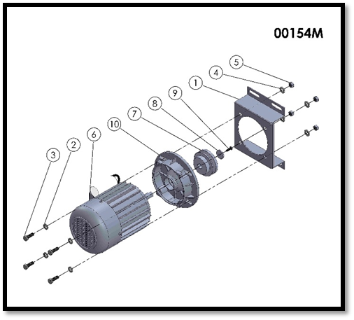
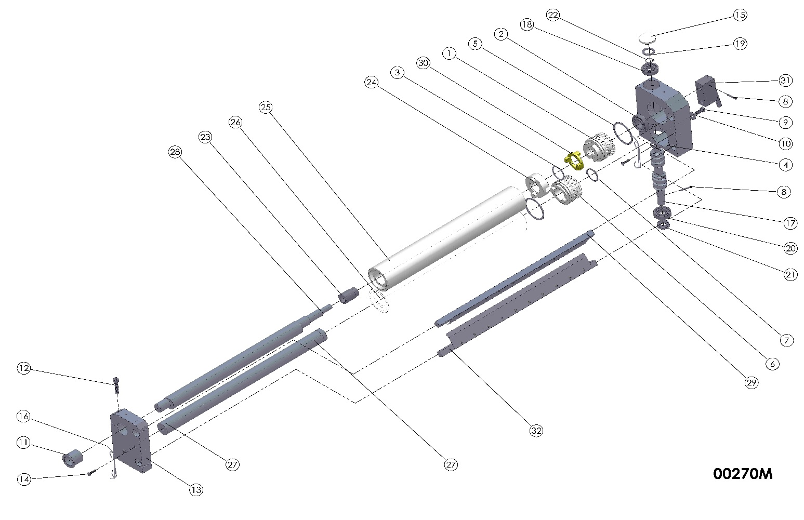
00270M (ROLLER GROUP) SPARE PARTS LIST
ITEM NO. | SPARE PART NUMBER | DESCRIPTION OF THE SPARE PART | UNIT |  | ITEM NO. | SPARE PART NUMBER | DESCRIPTION OF THE SPARE PART | UNIT
1 | 00204 | GEAR | 1 |  | 17 | 00206 | WORM GEAR | 1
2 | 00208 | BEARING | 1 |  | 18 | 00209 | BEARING | 1
3 | 00226 | O-RİNG | 1 |  | 19 | 00555 | WASHER | 2
4 | 00201 | GEAR BOX | 1 |  | 20 | 00207 | BEARING | 1
5 | 00228 | SHIFT SEGMENT | 2 |  | 21 | 00565 | THIMBLE | 1
6 | 00205 | GEAR | 1 |  | 22 | 00211 | SEGMENT | 1
7 | 00249 | SEGMENT | 1 |  | 23 | 00570 | THIMBLE | 1
8 | 00096 | PIN | 2 |  | 24 | 00227 | ROLLER BREAK COUPLER | 1
9 | 00043 | BOLT | 2 |  | 25 | 00468 | ROLLER (TOP) | 1
10 | 00044 | WASHER | 2 |  | 26 | 00493 | ROLLER (BOTTOM) | 1
11 | 00222 | THIMBLE | 1 |  | 27 | 00472 | SHAFT | 1
12 | 00349 | BOLT | 1 |  | 28 | 00471 | CAMSHAFT | 1
13 | 00574 | ROLL BEARING | 1 |  | 29 | 00073M | ROLLER SCRAPER (BOTTOM)  (ALT) | 1
14 | 00047 | BOLT | 2 |  | 30 | 00218 | ROLLER BREAK COUPLER | 1
15 | 00219 | COVER | 1 |  | 31 | 00263M | CONTROL LEVER GROUP | 1
16 | 00267 | SCRAPER SPRING | 4 |  | 32 | 00265M | ROLLER SCRAPER (TOP) | 1

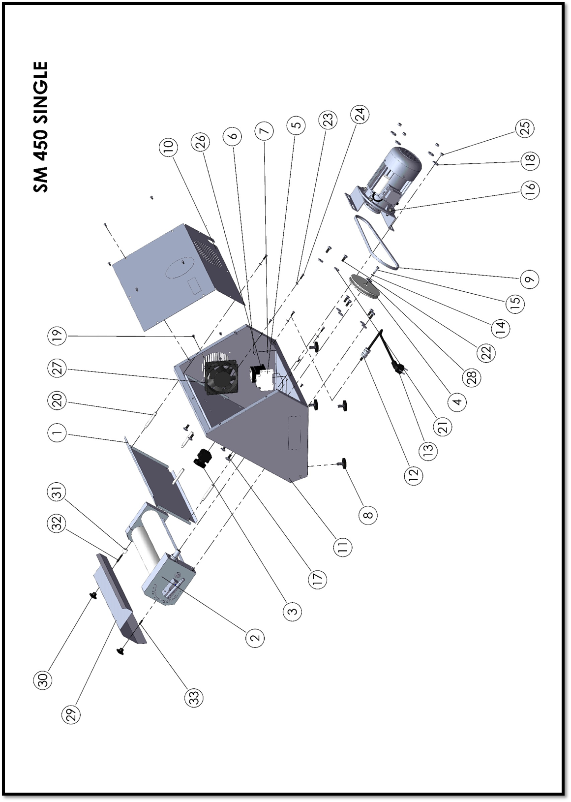

SM-450 SINGLE BODY SPARE PART LIST
ITEM NO. | SPARE PART NUMBER | DESCRIPTION OF THE SPARE PART | UNIT |  | ITEM NO. | SPARE PART NUMBER | DESCRIPTION OF THE SPARE PART | UNIT
1 | 00483 | DOUGH FEEDER SHEET | 1 |  | 18 | 01258 | WASHER | 4
2 | 00270M | ROLLER GROUP | 1 |  | 19 | 00046 | BOLT | 12
3 | 00055 | BUTTON | 1 |  | 20 | 00132 | MIDDLE WAY SHEET PIN (TALL | 4
4 | 00213 | V BELT PULLEY | 1 |  | 21 | 00044 | WASHER | 6
5 | 00057 | FUSE | 1 |  | 22 | 00043 | BOLT | 6
6 | 00298 | NUT | 4 |  | 23 | 00051 | WASHER | 4
7 | 01960 | PLAIN WASHER | 4 |  | 24 | 00049 | BOLT | 4
8 | 00354 | STAYS | 4 |  | 25 | 01959 | NUT | 4
9 | 00502 | V BELT | 1 |  | 26 | 00056 | CONTACTOR | 1
10 | 00156M | BACK PLATE | 1 |  | 27 | 00059 | VENTILATING FAN | 1
11 | 00157M | BODY | 1 |  | 28 | 00006 | WASHER | 1
12 | 00097 | CABLE GLAND | 1 |  | 29 | 00590 | COVER PLATE | 1
13 | 00355 | PRINTED POWER LEAD | 1 |  | 30 | 00124 | BAKALİTE | 2
14 | 00042 | PLAIN WASHER | 1 |  | 31 | 00153 | WEDGE | 1
15 | 00041 | BOLT | 1 |  | 32 | 00549 | STAY BOLT | 1
16 | 00154M | ENGINE | 1 |  | 33 | 00121 | STAY BOLT | 1
17 | 00476 | BOLT | 4 |  | 34

 | 00154M SPARE PART LIST
ITEM NO | SPARE PART NUMBER | DESCRIPTION OF THE SPARE PART | UNIT
1 | 00503 | ENGINE SHEET | 1
2 | 01963 | WASHER | 4
3 | 04072 | BOLT | 4
4 | 01961 | PLAIN WASHER | 4
5 | 01959 | NUT | 4
6 | 00023 | ENGINE | 1
7 | 00253 | PULLEY | 1
8 | 00098 | PULP | 1
9 | 00049 | BOLT | 1
10 | 00040 | PLATE | 1
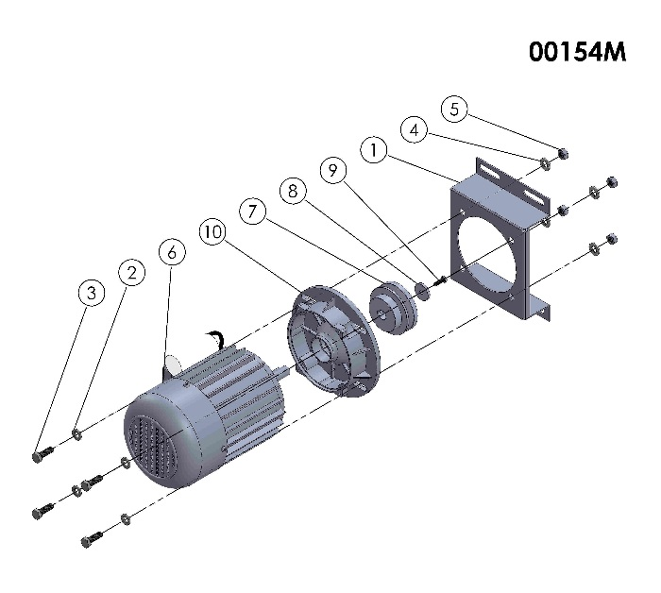

00269M (ROLLER GROUP) SPARE PARTS LIST
ITEM NO. | SPARE PART NUMBER | DESCRIPTION OF THE SPARE PART | UNIT |  | ITEM NO. | SPARE PART NUMBER | DESCRIPTION OF THE SPARE PART | UNIT
1 | 00566 | CAMSHAFT | 1 |  | 17 | 00226 | O-RING | 1
2 | 00248 | BOTTOM ROLLER SHAFT (BOTTOM) | 1 |  | 18 | 00096 | PIN | 2
3 | 00264 | BOTTOM ROLLER (UPPER) | 1 |  | 19 | 00219 | CUP | 1
4 | 00259 | BOTTOM ROLLER(BOTTOM) | 1 |  | 20 | 00206 | WORM GEAR | 1
5 | 00201 | GEAR BOX | 1 |  | 21 | 00565 | THIMBLE | 1
6 | 00574 | ROLL BEARING | 1 |  | 22 | 00207 | BEARING | 2
7 | 00222 | THIMBLE | 1 |  | 23 | 00555 | WASHER | 1
8 | 00570 | THIMBLE | 1 |  | 24 | 00265M | ROLLER SCRAPER | 28
9 | 00208 | BEARING | 1 |  | 25 | 00047 | BOLT | 1
10 | 00205 | GEAR | 1 |  | 26 | 00267 | SCRATCH SPRING | 2
11 | 00249 | RING | 1 |  | 27 | 00349 | BOLT | 2
12 | 00228 | GEAR RING | 2 |  | 28 | 00354M | ROLLER SCRAPER ( BOTTOM) | 1
13 | 00043 | SHIFT SEGMENT | 2 |  | 29 | 00263M | CONTROL LEVER GROUP | 1
14 | 00044 | WASHER | 2 |  | 30 | 00227 | ROLLER BREAK COUPLER | 1
15 | 00204 | GEAR | 1 |  | 31 | 00211 | SEGMENT | 1
16 | 00218 | MIDDLE COUPLING | 1
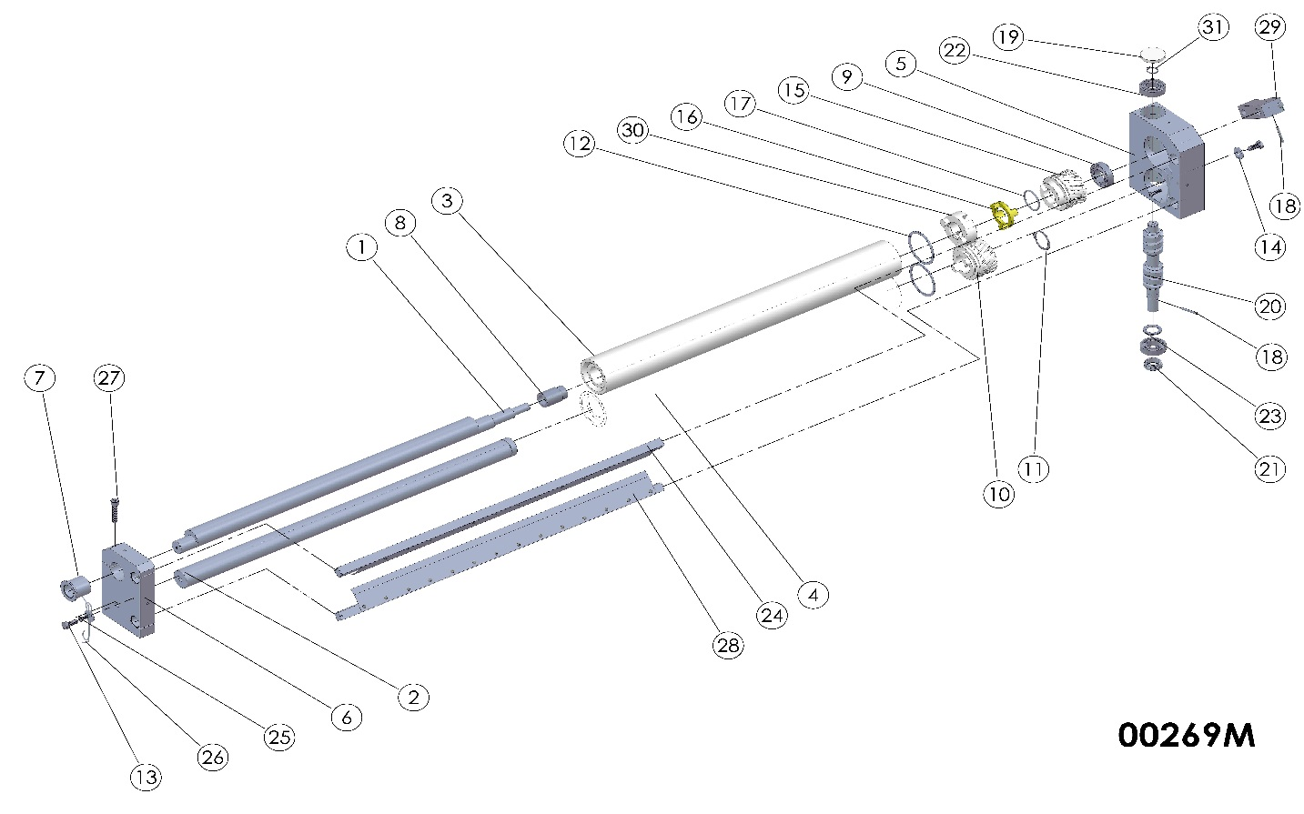
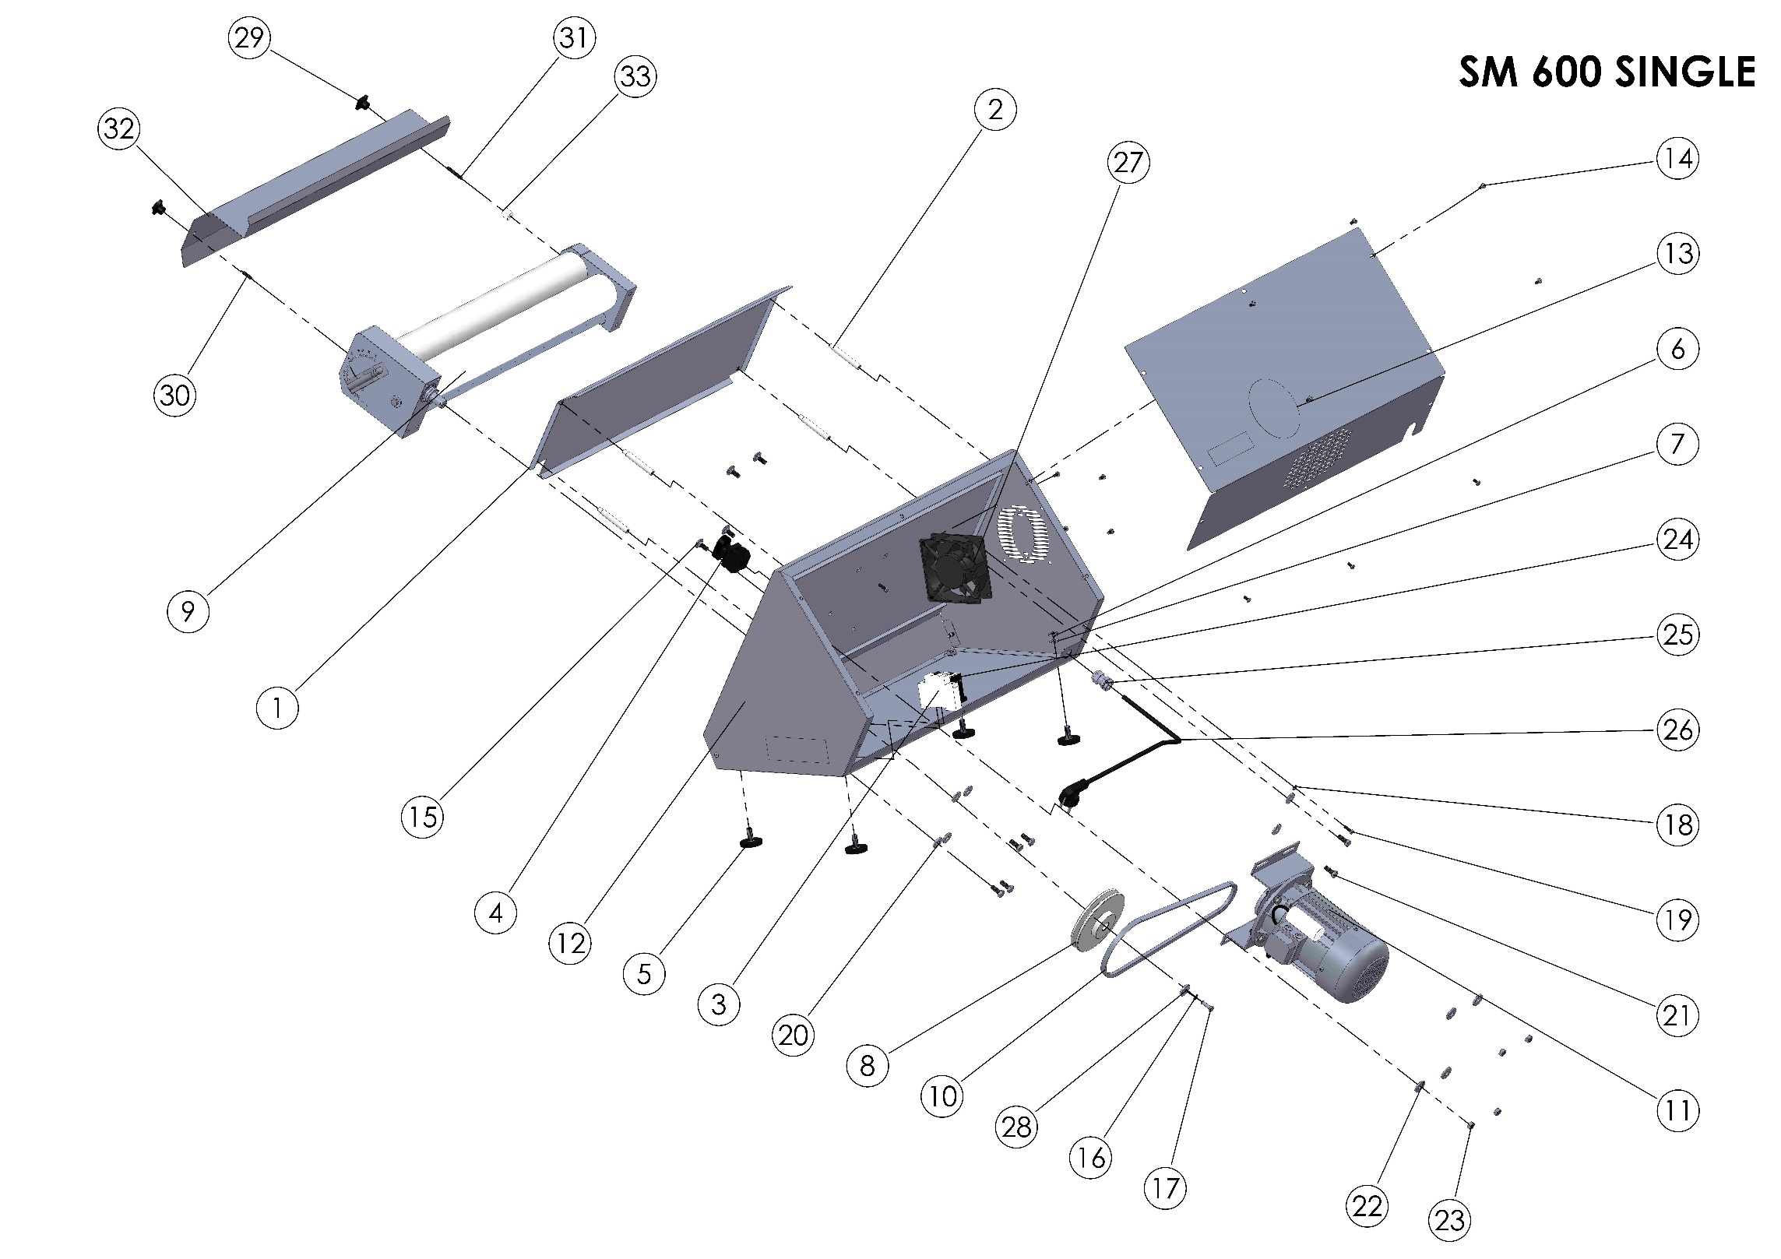

SM-600 SINGLE BODY SPARE PARTS LIST
ITEM NO. | SPARE PART NUMBER | DESCRIPTION OF THE SPARE PART | UNIT |  | ITEM NO. | SPARE PART NUMBER | DESCRIPTION OF THE SPARE PART | UNIT
1 | 00494 | FEEFER PLATE | 1 |  | 18 | 00051 | WASHER | 4
2 | 00132 | MIDDLE WAY FEEDER PIN(TALL) | 4 |  | 19 | 00049 | BOLT | 3
3 | 00057 | FUSE | 1 |  | 20 | 00044 | WASHER | 6
4 | 00055 | BUTTON | 1 |  | 21 | 00043 | BOLT | 6
5 | 00354 | STAYS | 4 |  | 22 | 01258 | WASHER | 4
6 | 00298 | NUT | 4 |  | 23 | 01959 | NUT | 4
7 | 01960 | PLAIN WASHER | 4 |  | 24 | 00056 | CONTACTOR | 1
8 | 00212 | PULLEY | 1 |  | 25 | 00097 | RECORD | 1
9 | 00269M | ROLLER GROUP | 1 |  | 26 | 00355 | ELECTRIC CABLE | 1
10 | 00502 | BELT | 1 |  | 27 | 00059 | FAN | 1
11 | 00154M | ENGINE | 1 |  | 28 | 00544 | BRACKET PLAIN | 2
12 | 00162M | BODY | 1 |  | 29 | 00124 | BAKALITE | 2
13 | 00163M | BACK PLATE | 1 |  | 30 | 00121 | STAY BOLT | 1
14 | 00046 | BOLT | 12 |  | 31 | 00549 | STAY BOLT | 1
15 | 00476 | BOLT | 4 |  | 32 | 00588 | COVER PLATE | 1
16 | 00042 | WASHER | 1 |  | 33 | 00153 | WEDGE | 1
17 | 00041 | BOLT | 1 |  | 34

00154M SPARE PART LİST
ITEM NO. | SPARE PART NUMBER | DESCRIPTION OF THE SPARE PART |  | UNIT
1 | 00503 | ENGINE PLATE |  | 1
2 | 01963 | WASHER |  | 4
3 | 04072 | BOLT |  | 4
4 | 01961 | PLAIN WASHER |  | 4
5 | 01959 | NUT |  | 4
6 | 00023 | ENGINE |  | 1
7 | 00253 | PULLEY |  | 1
8 | 00098 | PULP |  | 1
9 | 00049 | BOLT |  | 1
10 | 00040 | BRACKETS |  | 1

SECTION 6: ELECTRICAL DIAGRAM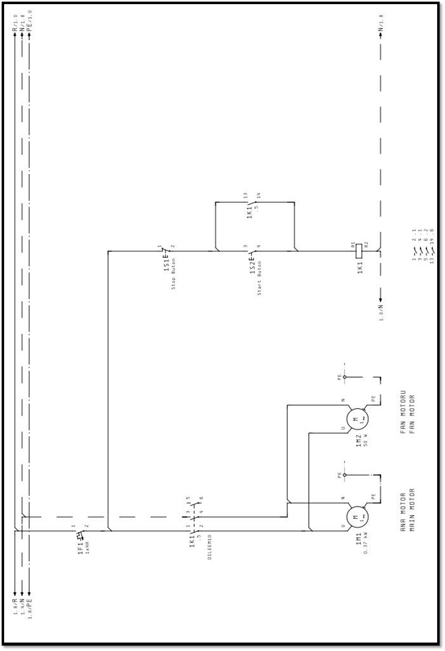

ŞENGÜN MAKİNA İNŞAAT VE KIRTASİYE SAN. TİC. LTD. ŞTİ.
İkitelli Organize Sanayi Bölgesi, Atatürk Bulvarı, Pufa İş Merkezi No: 98 Bodrum Kat: 2-3
Başakşehir/ İstanbul/ Türkiye

Phone: +90 212 671 23 23 (Pbx)
Phone 2: +90 212 671 84 84
Fax: +90 212 671 88 28
GSM: +90 533 957 14 53

e-Mail : info@sengunmakina.com
web : www.sengunmakina.com

