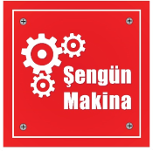

MODEL
SM-55YD, SM-60YD
DOUGH ROLLING MACHINE (HORIZONTAL FLAT)
SM-55YH, SM-60YH
DOUGH ROLLING MACHINE (HORIZONTAL SPEED CONTROL)

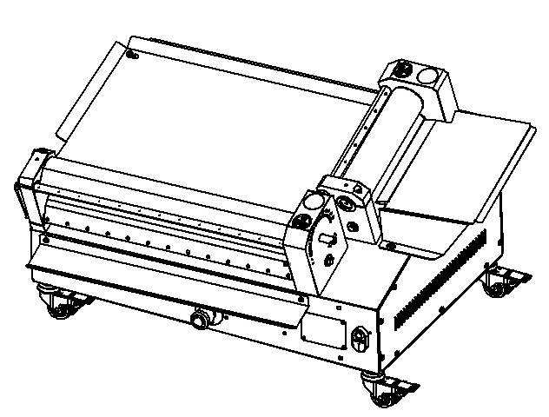

USER & MAINTENANCE MANUAL

ŞENGÜN MAKİNA İNŞAAT ve KIRTASİYE SAN. TİC. LTD. ŞTİ

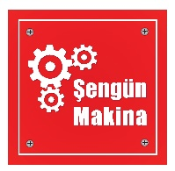
WARRANTY CERTIFICATE
SERIAL NUMBER :
SALE DATE :
Sold at the above date SM – ..……… MODEL DOUGH ROLL OUT MACHINE is guaranteed against production failures for 1 Year by ŞENGÜN MAKİNA İNŞAAT ve KIRTASİYE SAN. TİC. LTD. ŞTİ.

Warranty Terms;
- Warranty terms start after the product delivery for 1 Year.
- Recommended daily working time is 10 hours. The scope of warranty is assessed by year or by working hours.
- The product is under warranty except plastic rollers (included plastic rollers if it is a manufacturing defect).
- Documents are invalid, if haven’t sale date and confirm signature of company. You have to show the warranty certificate to benefit from the warranty.
- Device is guaranteed against defects if mount and use as described in the use and maintenance manual.
- Detection the location of defects, and elimination of the problems are responsibilities of the ŞENGUN MAKİNA…
- Warranty terms include only one device. You can’t claim any rights or compensation for another device.
- If Changes are made at the type, model and serial numbers, the warranty eliminates.
- If material, worker or assembly defects appear, repaired free by ŞENGÜN MAKİNA at the product warranty period (Transportation cost is not included).
- Failures are only repaired by ŞENGÜN MAKİNA’s personal. The intervention of unauthorized person, cancel the appliance of warranty.
- Installation have to be done by ŞENGÜN MAKİNA’s personal. İf usage place changes, customer must give information to ŞENGÜN MAKİNA
- In the event of failure service must be informed.
- The failures and damages given by external factors are out of the warranty terms.
- Any failure of the product warranty period is added to the product warranty time. The repair time is until 20 working days.
AUTHORIZED PERSON

STAMP –SIGNATURE

PRESENTATION

Dear Users,
Thank you for your prefer our machine and confidence in our company. Our machines are used in 39 countries.
Our machine is manufactured according to international standards. Please read the operating manual to get the mast out of your machine. Please note the following warnings before calling our service.

ŞENGÜN MAKİNA

- Please read the manuel carefully before installing the machine.
- The machine will be out of warranty when your operate the machine with at read.
- Please read carefully the manual that gives you information on the installation is prepared in accordance with the legal regulations before arriving at the machine installation.
- For information you coonot understand, ask your nearest out horized service
- Please note that if the technical service personnel is kept waiting you will be billed for each hour.

CONTENTS
WARRANTY CERTIFICATE

PRESENTATION

SECTION 1: INTRODUCTION
1.1 General Introduction of Dough Rolling Machine Model: SM-55, SM-60
1.2 Technical Specifications Table
1.3 Safety Warnings Labels

SECTION 2: INTRODUCTION OF MACHINE BODY COMPONENTS

SECTION 3: INSTRUCTIONS FOR USE
3.1 Usage Recommendations
3.2 Safety Warnings
3.3 Operating and Starting Instructions

SECTION 4: MAINTENANCE INSTRUCTIONS
4.1 Exterior Body Maintenance
4.2 Scraping Knife Maintenance

BÖLÜM 5: HA-55 YH, HA-60 YH SPARE YUFKA OPENING MACHINE SPEED CONTROL INSTRUCTION MANUAL

SECTION 6: SPARE PARTS MANUAL
6.1 SM-55 YD Spare Parts
6.2 SM-55 YH Spare Parts
6.3 SM-60 YD Spare Parts
6.4 SM-60 YH Spare Parts

SECTION 7: ELECTRICAL DIAGRAM
7.1 SM-55 YD / SM-60 YD Electrical Diagram
7.2 SM-55 YH / SM-60 YH Electrical Diagram

SECTION 1: INTRODUCTION
  - General Introduction of Dough Rolling Machine Model: SM-55, SM-60:
Uses at lahmacun, pizza and other dough rolling processes. Dough thickness and diameter get easy with roller gap adjustment system. Dough rolling process perform in min. 6, max. 8 seconds with fast and easy using feature.

  - Technical Specifications Table:
Technical Specifications Table | SM-55YD | SM-55YH | SM-60YD | SM-60YH
Length (cm) | 59 | 59 | 63 | 63
Width (cm) | 93 | 93 | 99 | 99
Height (cm) | 52 | 52 | 55 | 55
Machine Weight (Kg) | 64 | 64 | 68,2 | 68,2
Engine Power (kW) | 0.75 | 0,55 | 0.75 | 0,55
Electrical Specifications (V-HZ) | 230V 50/60HZ | 230V 50/60HZ | 230V 50/60HZ | 230V 50/60HZ
Maximum Dough Weight (gr) | 450 | 450 | 450 | 450
Dough Diameter (cm) | 26-55 | 26-55 | 26-60 | 26-60
Roller Range (mm) | 0-2 | 0-2 | 0-2 | 0-2
Hourly Production Quantity | 450-600 | 450-600 | 450-600 | 450-600

1.3 Safety Warnings Labels:
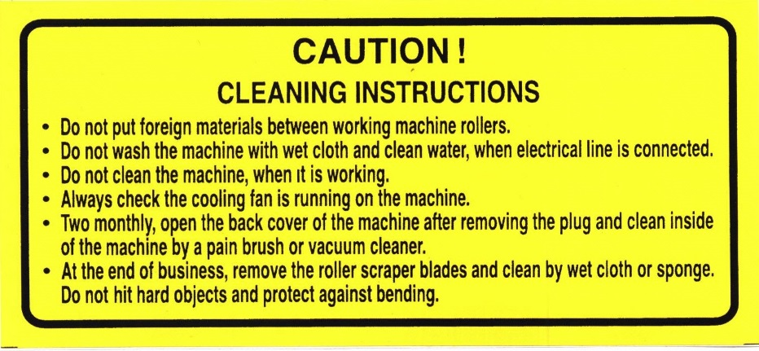
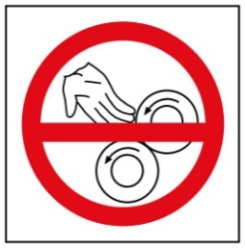

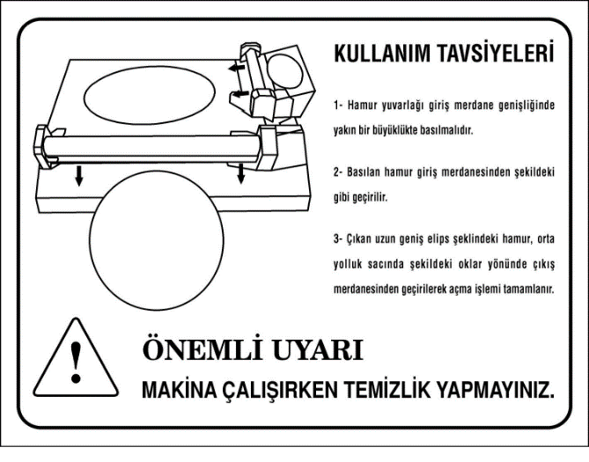

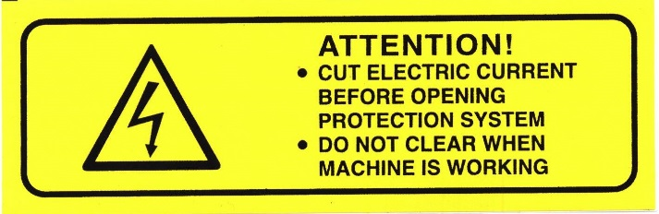

SECTION 2: INTRODUCTION OF MACHINE BODY COMPONENTS

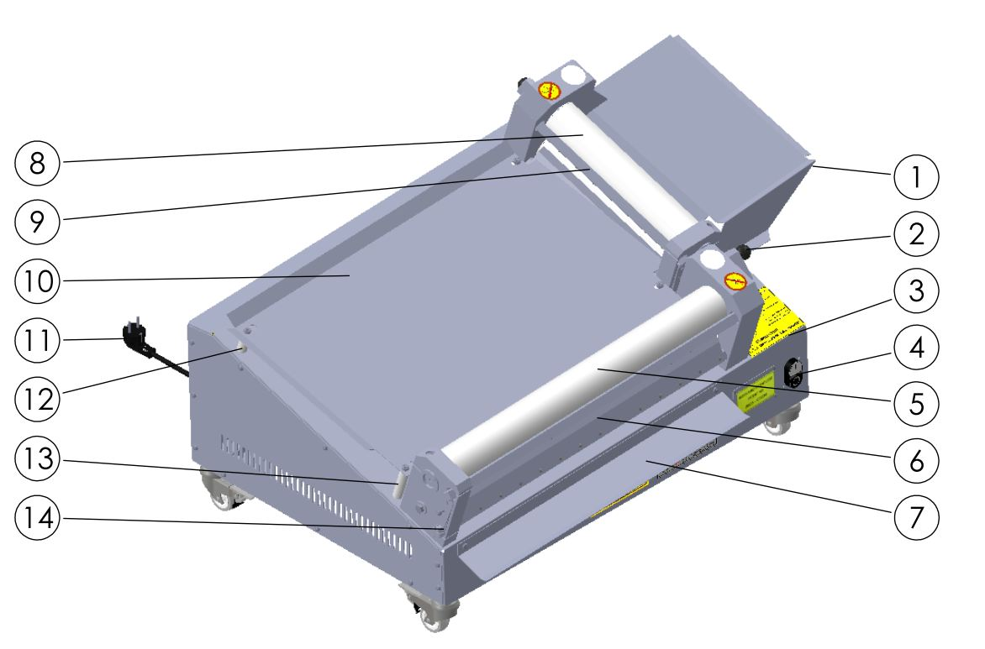

PART DESCRIPTION
1 | ENTRANCE PLATE | 8 | TOP ROLLERS
2 | ADJUSTING LEVER | 9 | TOP ROLLERS SCRAPERS
3 | BODY | 10 | CENTRAL PLATE
4 | START/STOP SWITCH | 11 | POWER CABLE
5 | BOTTOM ROLERS | 12 | CENTRAL PLATE PIN (SHORT)
6 | BOTTOM ROLERS SCRAPERS | 13 | CENTRAL PLATE PIN (LONG)
7 | OUT PLATE | 14 | SCRAPERS WİRE

SECTION 3: INSTRUCTIONS FOR USE

3.1 Usage Recommendations:

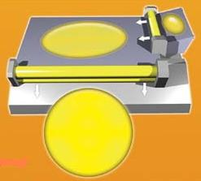

- Compress the dough and make it circular.
- Pass through the dough to the entrance roller gap shown in figure.
- Pass through the dough to the exit roller gap from midway tray shown in figure.

3.2 Safety Warnings:

- Secure voltage is between 230 V and 240 V
- Set up on a straight floor.
- Single phase on operating.
- Don’t wipe the machine with a wet cloth when connect to plug.
- Cut electric current before opening protection system.
- Check the air intake of the cooling fan daily.

3.3 Operating and Starting Instructions:

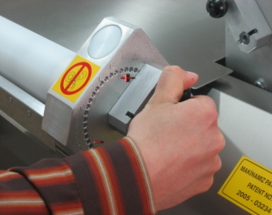
- Connect to mono phase electrical supply.
- Push the “I” button.
- Adjust the roller gap shown in picture. (This procedure adjust the dough thickness and diameter)

Adjust the dough thickness from “0” to “20” shown in figure.
- Pull back the bakelite knob and rotate the knob to “+” or “-” direction.
- Rotate the knob to “+” direction for enlarge the dough thickness. Rotate the knob to “-” direction for reduce the dough thickness.
- Push the bakelite knob when the intended roller gap adjusted.

NOTE: Entrance roller gap advice to be bigger than the exit roller gap.
NOTE: Scrapers must be stretched.
SECTION 4: MAINTENANCE INSTRUCTIONS
4.1 Exterior Body Maintenance:
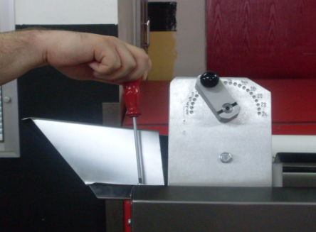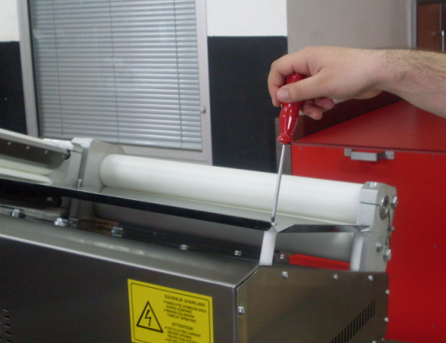
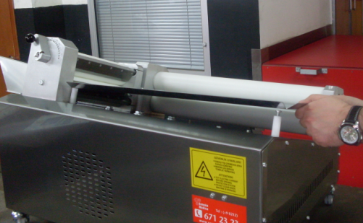
Pull up the entrance and central PLATEs shown in picture then clean the flour and crumbs. Stop the machine and unplug the electrical supply then clean with wet cloth. Don’t plug the electrical supply before the machine dry.

4.2 Scrapers Maintenance:
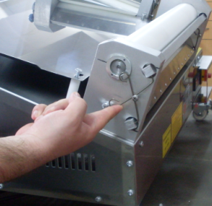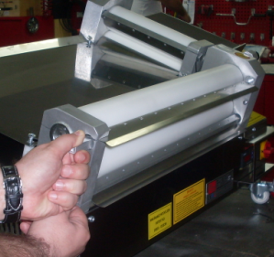
- Push up scrapers wire as shown in the figure
- Remove the scrapers from the hole as shown in the figure and clean the scrapers daily.

  - Out Plate Maintenance:

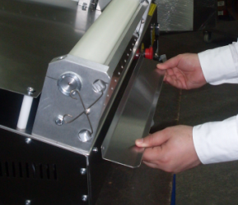
- Take down the bolts. Clean the out PLATE and assemble it back.

SECTION 5: SM-55 YH / SM-60 YH DOUGH ROLLING SPEED CONTROL INSTRUCTIONS FOR USE

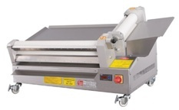

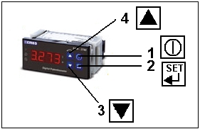

THE PACCO SWITCH IS OPENED AND ENERGY IS GIVEN TO THE MACHINE;
- Press the power button to start speed control.

- Press (SET) button to change roller speed with speed control. The speed value will start flashing on the screen, cycle change should be done at this time. Change the speed value with the down (3), up (4) direction buttons. Save the changed speed value by pressing (SET). (If the speed value flashes four times after pressing the SET button, the recording is done.)

- Press up (4) to turn the rollers in reverse direction. When we repeat the same process, the direction of movement will return to the direction of work.

SECTION 6: SPARE PARTS

6.1 SM-55 YD Spare Parts Manual:
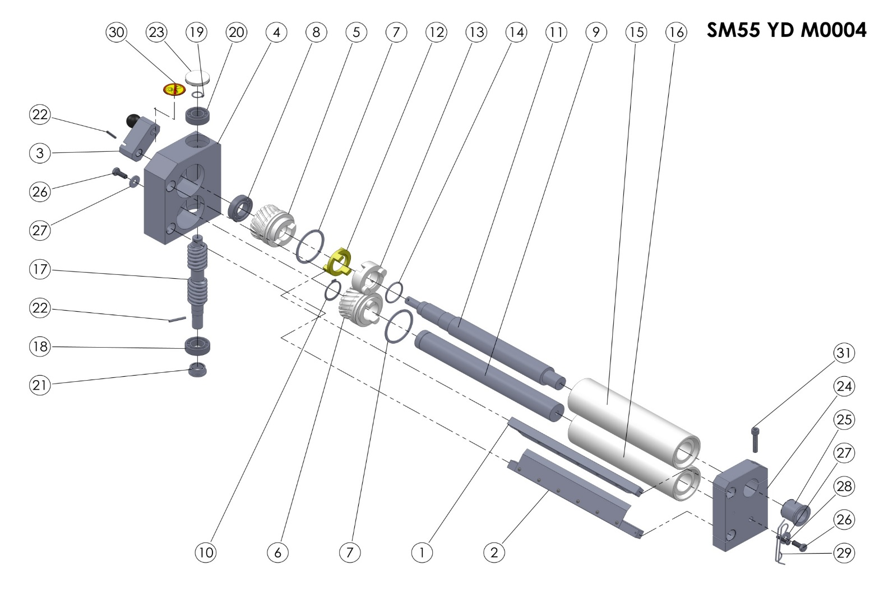
TOP ROLLER GROUP

SM55 YD M0004 (TOP ROLLER GROUP) SPARE PARTS LIST
ITEM | SPARE PART NUMBER | SPARE PART DESCRIPTION | UNIT |  | ITEM | SPARE PART NUMBER | SPARE PART DESCRIPTION | UNIT
1 | 00346M | ROLLER SCRAPERS (TOP) | 1 |  | 17 | 00206 | WORM | 1
2 | 00347M | ROLLER SCRAPERS (BOTTOM) | 1 |  | 18 | 00207 | BEARING | 1
3 | 00348M | ADJUSTING LEVER | 1 |  | 19 | 00211 | RING | 1
4 | 00203 | GEARBOX | 1 |  | 20 | 00209 | BEARING | 1
5 | 00204 | GEAR (FEMALE) | 1 |  | 21 | 00210 | THIMBLE | 1
6 | 00205 | GEAR (MALE) | 1 |  | 22 | 00096 | PIN | 2
7 | 00228 | RING | 2 |  | 23 | 00219 | COVER | 1
8 | 00208 | BEARING | 1 |  | 24 | 00202 | ROLLER BEARING | 1
9 | 00244 | SHAFT (BOTTOM) | 1 |  | 25 | 00222 | THIMBLE | 1
10 | 00249 | RING | 1 |  | 26 | 00043 | BOLT | 2
11 | 00239 | SHAFT (TOP) | 1 |  | 27 | 00044 | WASHER | 2
12 | 00218 | CLUTCH | 1 |  | 28 | 00266 | BOLT | 1
13 | 00227 | CLUTCH | 1 |  | 29 | 00267 | SCRAPERS WIRE | 2
14 | 00226 | O-RİNG | 1 |  | 30 | 00037 | LABEL | 1
15 | 00260 | ROLLER (TOP) | 1 |  | 31 | 00349 | BOLT | 1
16 | 00255 | ROLLER (BOTTOM) | 1

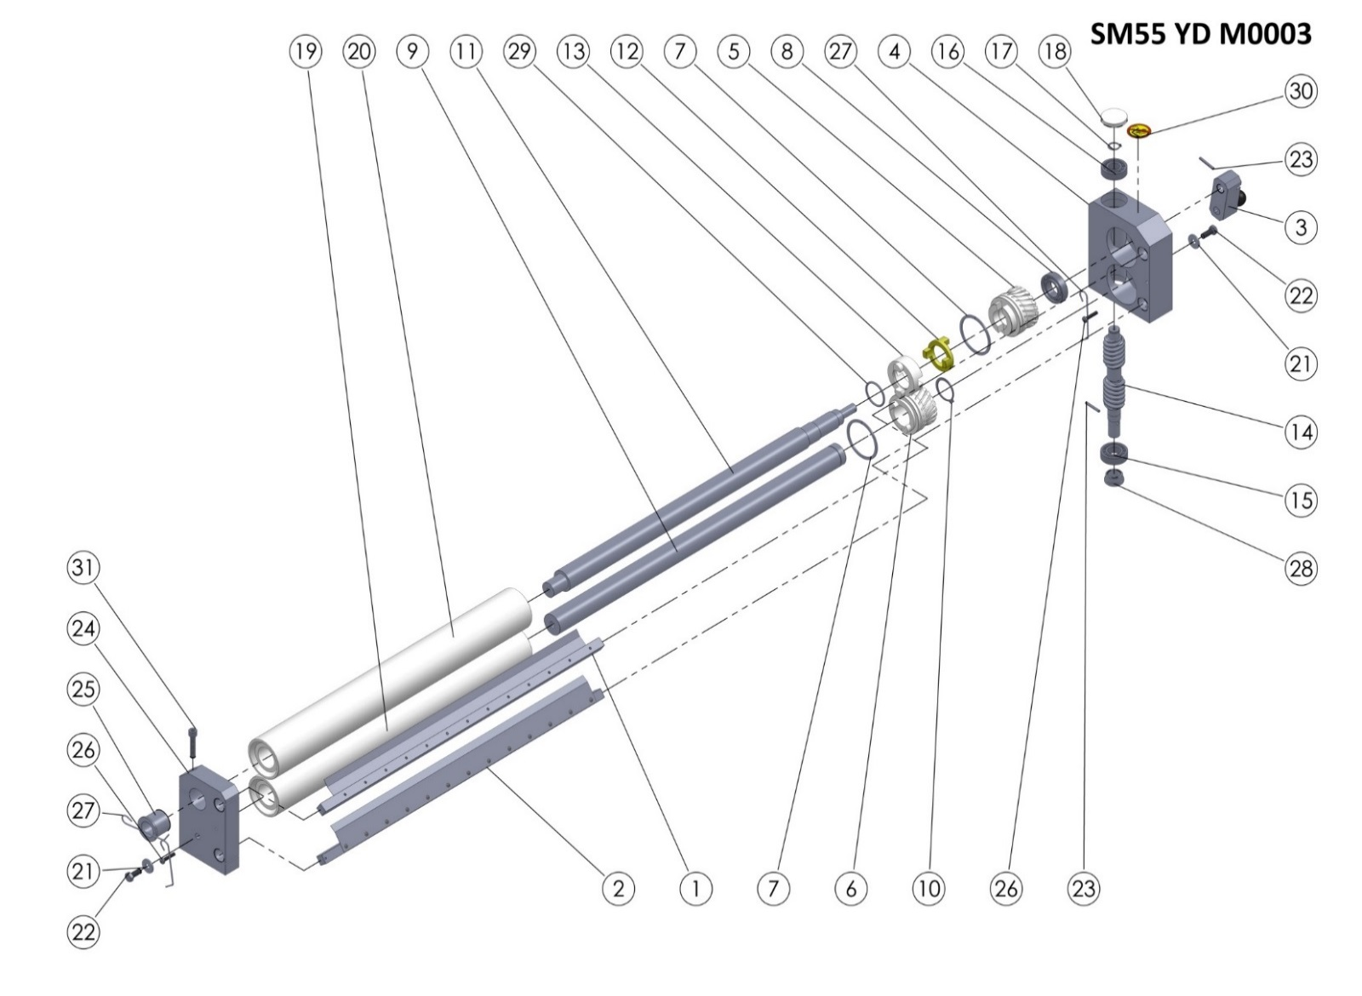

SM55 YD M0003 BOTTOM ROLLER GROUP

SM55 YD M0003 (BOTTOM ROLLER GROUP) SPARE PARTS LIST
ITEM | SPARE PART NUMBER | SPARE PART DESCRIPTION | UNIT |  | ITEM | SPARE PART NUMBER | SPARE PART DESCRIPTION | UNIT
1 | 00344M | ROLLER SCRAPER (TOP) | 1 |  | 17 | 00211 | RING | 1
2 | 00345M | ROLLER SCRAPER (BOTTOM) | 1 |  | 18 | 00219 | COVER | 1
3 | 00348M | ADJUSTING LEVER | 1 |  | 19 | 00258 | ROLLER (BOTTOM) | 1
4 | 00201 | GEARBOX | 1 |  | 20 | 00263 | ROLLER (TOP) | 1
5 | 00204 | GEAR (FEMALE) | 1 |  | 21 | 00044 | WASHER | 2
6 | 00205 | GEAR (MALE) | 1 |  | 22 | 00043 | BOLT | 2
7 | 00228 | GEAR RING | 2 |  | 23 | 00096 | PIN | 2
8 | 00208 | BEARING | 1 |  | 24 | 00200 | ROLLER BEARING | 1
9 | 00247 | SHAFT(BOTTOM) | 1 |  | 25 | 00222 | THIMBLE | 1
10 | 00249 | RING | 1 |  | 26 | 00266 | BOLT | 2
11 | 00242 | SHAFT (TOP) | 1 |  | 27 | 00267 | SCRAPERS WIRE | 3
12 | 00218 | CLUTCH | 1 |  | 28 | 00210 | THIMBLE | 1
13 | 00227 | CLUTCH | 1 |  | 29 | 00226 | O-RİNG | 1
14 | 00206 | WORM | 1 |  | 30 | 00037 | LABEL | 1
15 | 00207 | BEARING | 1 |  | 31 | 00349 | BOLT | 1
16 | 00209 | BEARING | 1

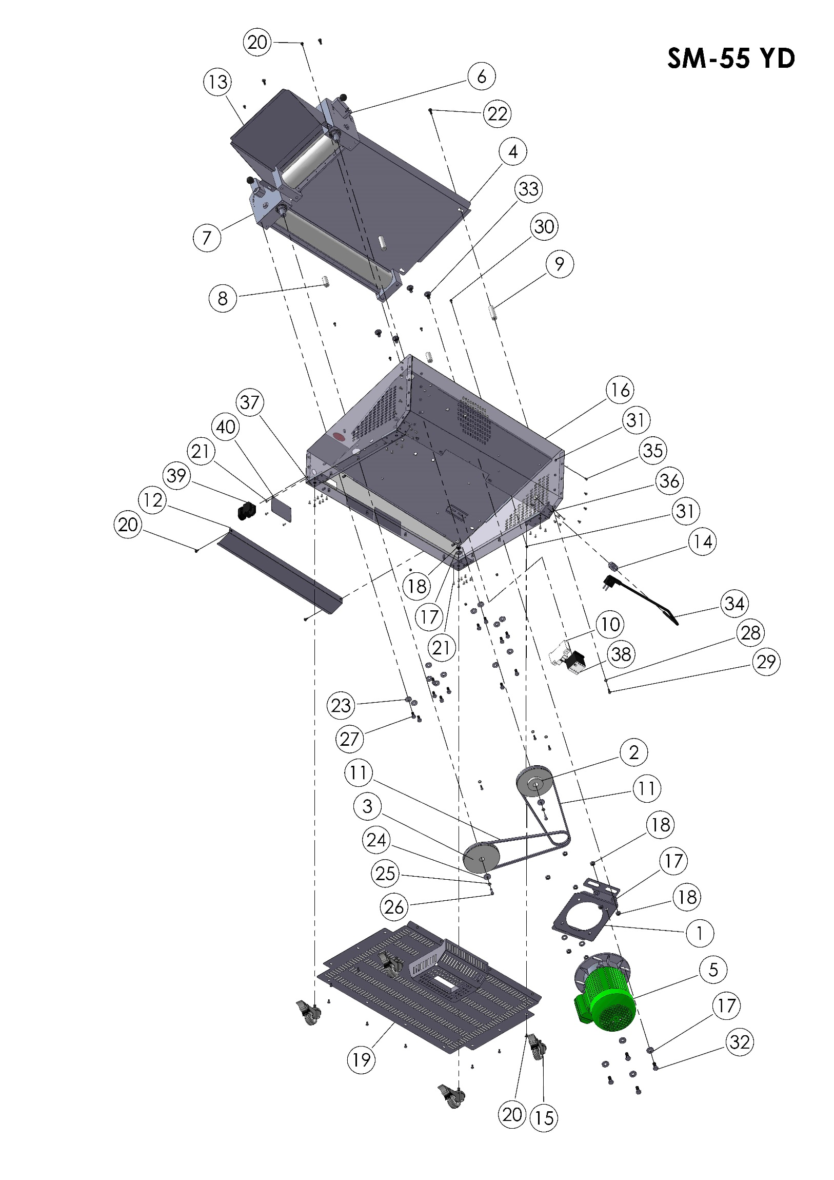
SM55 YD BODY

SM55 YD BODY SPARE PARTS LIST
ITEM | SPARE PART NUMBER | SPARE PART DESCRIPTION |  | UNIT |  |  | ITEM | SPARE PART NUMBER | SPARE PART DESCRIPTION |  | UNIT
1 | 00480  00480 | ENGINE PLATE |  | 1 |  |  | 21 | 01529 | RIVET |  | 36
2 | 00212 | PULLEY |  | 1 |  |  | 22 | 00291 | BOLT |  | 4
3 | 00213 | V BELT PULLEY |  | 1 |  |  | 23 | 00044 | WASHER |  | 12
4 | 00285 | MIDDLE FEEDER PLATE |  | 1 |  |  | 24 | 00006 | WASHER |  | 2
5 | SM55 YD M0001 | ENGINE |  | 1 |  |  | 25 | 00042 | PLAİN WASHER |  | 2
6 | SM55 YD M0004 | UPPER ROLLER GROUP (COMPLETE) |  | 1 |  |  | 26 | 00041 | BOLT |  | 2
7 | SM55 YD M0007 | BOTTOM ROLLER GROUP(COMPLETE) |  | 1 |  |  | 27 | 00043 | BOLT |  | 12
8 | 00289 | MIDDLE FEEDER PLATE PIN (SHORT) |  | 2 |  |  | 28 | 00051 | WASHER |  | 4
9 | 00276 | MIDDLE FEEDER PLATE PIN (LONG) |  | 2 |  |  | 29 | 00049 | BOLT |  | 4
10 | 00301 | FUSE |  | 1 |  |  | 30 | 00048 | BOLT |  | 4
11 | 00299 | BELT |  | 2 |  |  | 31 | 00052 | NUT |  | 18
12 | 00537 | OUTPUT PLATE |  | 1 |  |  | 32 | 00279 | BOLT |  | 4
13 | 00535 | FEEDER PLATE |  | 1 |  |  | 33 | 00499 | BOLT |  | 4
14 | 00097 | COUPLİNG |  | 1 |  |  | 34 | 00403 | ELECTRIC CABLE |  | 1
15 | 00297 | WHEELS |  | 4 |  |  | 35 | 00157 | BOLT |  | 14
16 | 00201M | BODY |  | 1 |  |  | 36 | 00527 | WHEEL PLATE |  | 2
17 | 00277 | WASHER |  | 12 |  |  | 37 | 00528 | WHEEL PLATE |  | 2
18 | 00298 | NUT |  | 12 |  |  | 38 | 00300 | CONTAKTOR |  | 1
19 | 00198M | BASE PLATE |  | 1 |  |  | 39 | 00055 | BUTTON |  | 1
20 | 00278 | BOLT |  | 18 |  |  | 40 | 00302 | LABEL PLATE |  | 1
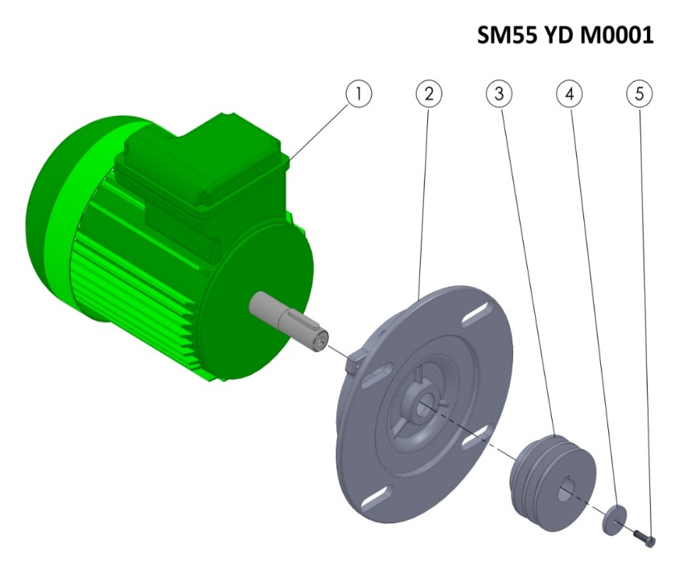
SM55 YD M0001 SPARE PARTS LIST
ITEM | SPARE PART NUMBER | SPARE PART DESCRIPTION | UNIT
1 | 00254 | ENGINE | 1
2 | 00252 | ENGINE FLANGE | 1
3 | 00214 | CASTING V BELT PULLEY | 1
4 | 00098 | WASHER | 1
5 | 00049 | BOLT | 1

6.2 SM-55 YH Spare Parts Manual:
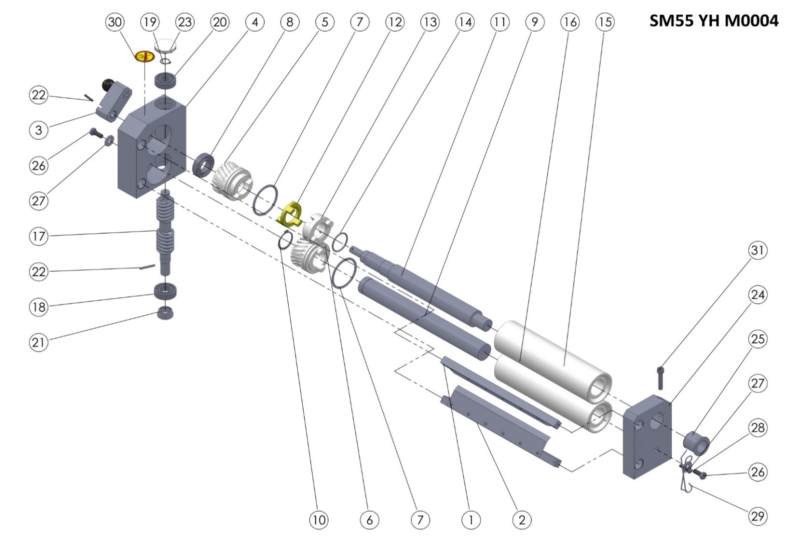
SM55 YH M0004 TOP ROLLER GROUP

SM55 YH M0004 (TOP ROLLER GROUP) SPARE PARTS LIST
ITEM NO | SPARE PART NUMBER | SPARE PART DESCRIPTION | UNIT |  | ITEM NO | SPARE PART NUMBER | SPARE PART DESCRIPTION | UNIT
1 | 00346M | ROLLER SCRAPERS (TOP) | 1 |  | 17 | 00206 | WORM | 1
2 | 00347M | ROLLER SCRAPERS (BOTTOM) | 1 |  | 18 | 00207 | BEARING | 1
3 | 00348M | ADJUSTING LEVER | 1 |  | 19 | 00211 | RING | 1
4 | 00203 | GEAR BOX | 1 |  | 20 | 00209 | BEARING | 1
5 | 00204 | GEAR (FEMALE) | 1 |  | 21 | 00210 | THIMBLE | 1
6 | 00205 | GEAR (MALE) | 1 |  | 22 | 00096 | PIN | 2
7 | 00228 | GEAR RING | 2 |  | 23 | 00219 | COVER | 1
8 | 00208 | BEARING | 1 |  | 24 | 00202 | ROLLER BEARING | 1
9 | 00244 | SHAFT (BOTTOM) | 1 |  | 25 | 00222 | THIMBLE | 1
10 | 00249 | RING | 1 |  | 26 | 00043 | BOLT | 2
11 | 00239 | SHAFT (TOP) | 1 |  | 27 | 00044 | WASHER | 2
12 | 00218 | CLUTCH | 1 |  | 28 | 00266 | BOLT | 1
13 | 00227 | ROLLER CLUTCH | 1 |  | 29 | 00267 | SCRAPER SPRING | 2
14 | 00226 | O-RING | 1 |  | 30 | 00037 | LABEL | 1
15 | 00260 | ROLLER (TOP) | 1 |  | 31 | 00349 | BOLT | 1
16 | 00255 | ROLLER (BOTTOM) | 1

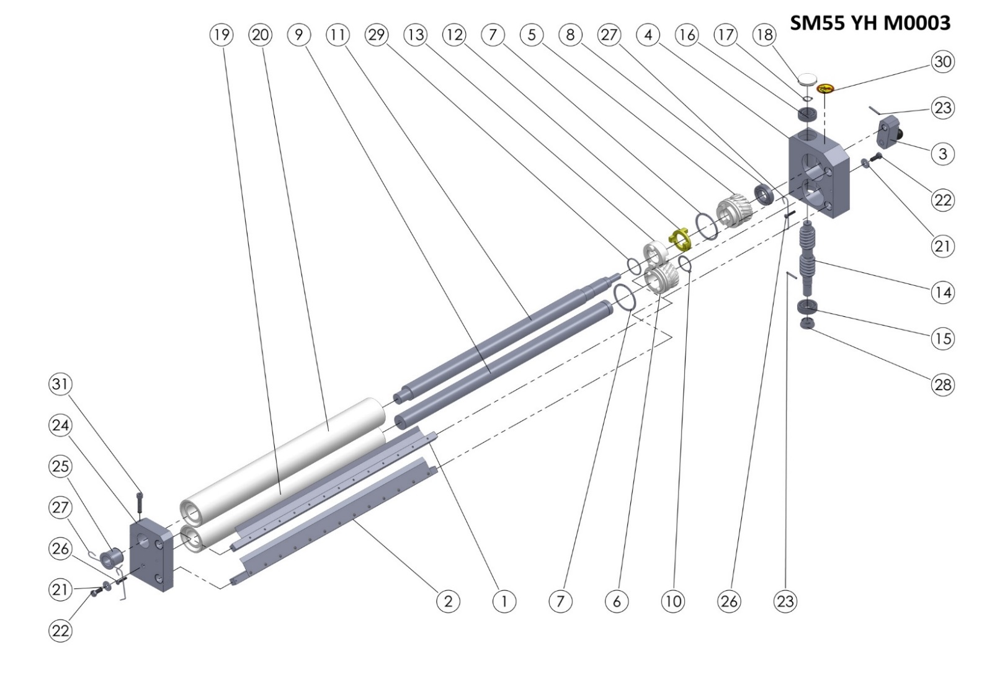
SM55 YH M0003 BOTTOM ROLLER GROUP

ITEM | SPARE PART NUMBER | SPARE PART DESCRIPTION | UNIT |  | ITEM | SPARE PART NUMBER | SPARE PART DESCRIPTION | UNIT
1 | 00344M | ROLLER SCRAPER (TOP) | 1 |  | 17 | 00211 | RING | 1
2 | 00345M | ROLLER SCRAPER (BOTTOM) | 1 |  | 18 | 00219 | COVER | 1
3 | 00348M | ADJUSTING LEVER | 1 |  | 19 | 00258 | ROLLER (BOTTOM) | 1
4 | 00201 | GEARBOX | 1 |  | 20 | 00263 | ROLLER (TOP) | 1
5 | 00204 | GEAR (FEMALE) | 1 |  | 21 | 00044 | WASHER | 2
6 | 00205 | GEAR (MALE) | 1 |  | 22 | 00043 | BOLT | 2
7 | 00228 | GEAR RING | 2 |  | 23 | 00096 | PIN | 2
8 | 00208 | BEARING | 1 |  | 24 | 00200 | ROLLER BEARING | 1
9 | 00247 | SHAFT (BOTTOM) | 1 |  | 25 | 00222 | THIMBLE | 1
10 | 00249 | RING | 1 |  | 26 | 00266 | BOLT | 2
11 | 00242 | SHAFT (TOP) | 1 |  | 27 | 00267 | SCRAPERS WIRE | 3
12 | 00218 | CLUTCH | 1 |  | 28 | 00210 | THIMBLE | 1
13 | 00227 | ROLLER CLUTCH | 1 |  | 29 | 00226 | O-RING | 1
14 | 00206 | WORM | 1 |  | 30 | 00037 | LABEL | 1
15 | 00207 | BEARING | 1 |  | 31 | 00349 | BOLT | 1
16 | 00209 | BEARING | 1
SM55 YH M0003 (BOTTOM ROLLER GROUP) SPARE PART LIST

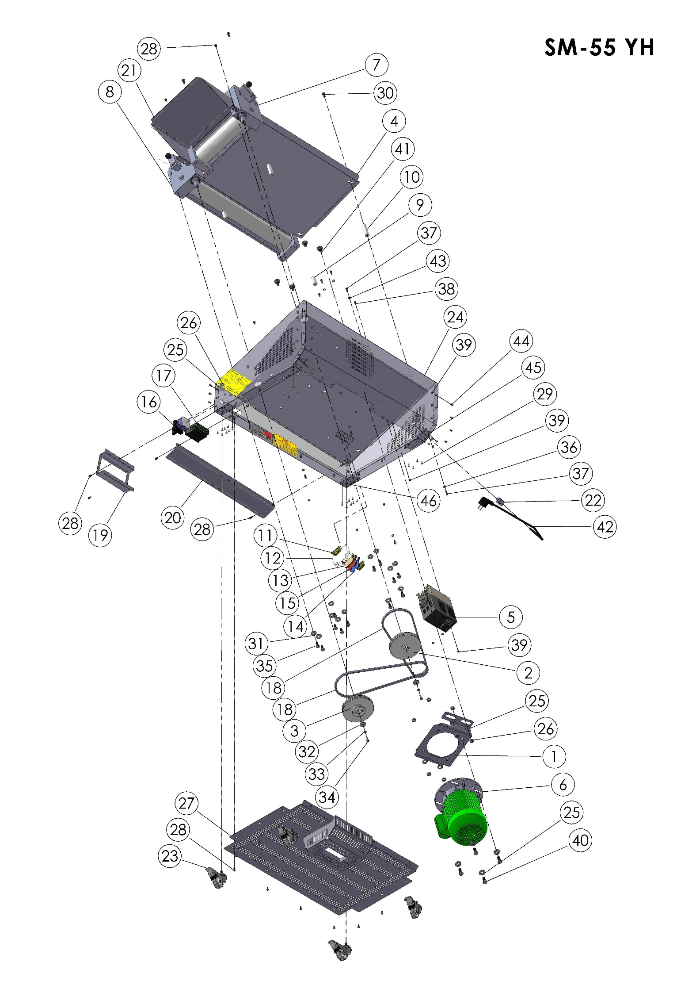
SM55 YH BODY

SM55 YH BODY SPARE PARTS LIST
ITEM | SPARE PART NUMBER | SPARE PART DESCRIPTION | UNIT |  | ITEM | SPARE PART NUMBER | SPARE PART DESCRIPTION | UNIT
1 | 00480 | ENGINE PLATE | 1 |  | 24 | 00201M | BODY | 1
2 | 00212 | PULLEY | 1 |  | 25 | 00277 | WASHER | 12
3 | 00213 | V BELT PULLEY | 1 |  | 26 | 00298 | NUT | 12
4 | 00285 | MIDDLE FEEDER PLATE | 1 |  | 27 | 00198M | BASE | 1
5 | 00384 | SPEED CONTROL | 1 |  | 28 | 00278 | BOLT | 20
6 | SM55 YD M0001 | ENGINE | 1 |  | 29 | 01529 | RIVET | 32
7 | SM55 YD M0004 | UPPER ROLLER GROUP (COMPLETE) | 1 |  | 30 | 00291 | BOLT | 4
8 | SM55 YD M0007 | BOTTOM ROLLER GROUP (COMPLETE) | 1 |  | 31 | 00044 | WASHER | 12
9 | 00289 | MIDDLE FEEDER PLATE PIN (SHORT) | 2 |  | 32 | 00006 | WASHER | 2
10 | 00276 | MIDDLE FEEDER PLATE PIN(LONG) | 2 |  | 33 | 00042 | PLAIN WASHER | 2
11 | 00292 | LIMITER | 2 |  | 34 | 00041 | BOLT | 2
12 | 00301 | FUSE | 1 |  | 35 | 00043 | BOLT | 12
13 | 00293 | CONNECTOR (GROUNDING) | 1 |  | 36 | 00051 | WASHER | 4
14 | 00294 | CONNECTOR (BLUE) | 1 |  | 37 | 00049 | BOLT | 7
15 | 00295 | CONNECTOR | 1 |  | 38 | 00048 | BOLT | 4
16 | 00224 | ON / OFF SWITCH | 1 |  | 39 | 00052 | NUT | 21
17 | 00250 | POTENTIOMETER | 1 |  | 40 | 00279 | BOLT | 4
18 | 00299 | BELT | 2 |  | 41 | 00499 | BOLT | 4
19 | 00522 | SWITCH PROTECTION VALVE | 1 |  | 42 | 00403 | ELECTRIC CABLE | 1
20 | 00537 | OUTPUT POLISH | 1 |  | 43 | 02582 | WASHER | 3
21 | 00535 | FEEDER PLATE | 1 |  | 44 | 00157 | BOLT | 14
22 | 00097 | COUPLİNG | 1 |  | 45 | 00527 | WHEEL PLATE | 2
23 | 00297 | WHEEL | 4 |  | 46 | 00528 | WHEEL PLATE | 2
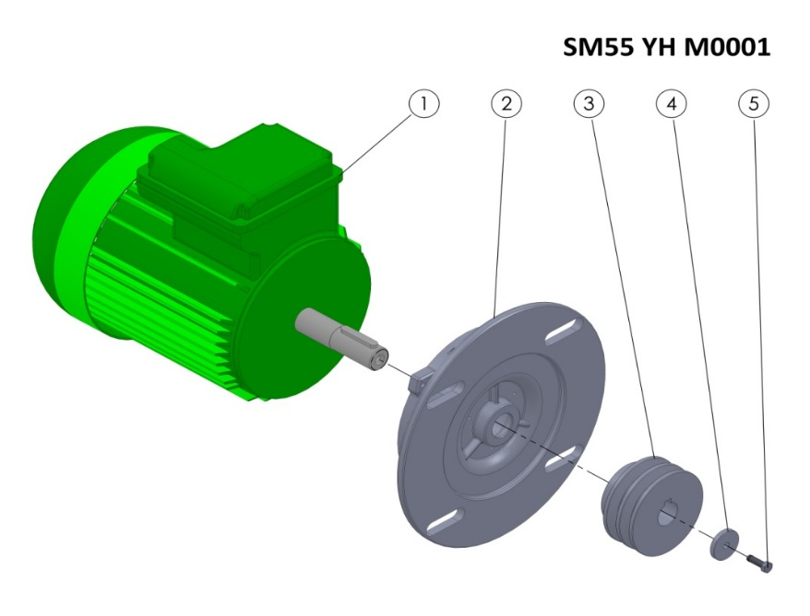
SM55 YH M0001 SPARE PARTS LIST
ITEM | SPARE PART NUMBER | SPARE PART DESCRIPTION | UNIT
1 | 00254 | ENGINE | 1
2 | 00252 | ENGINE FLANGE | 1
3 | 00214 | CASTING V BELT PULLEY | 1
4 | 00098 | WASHER | 1
5 | 00049 | WASHER | 1

6.3 SM-60 YD Spare Parts Manual:
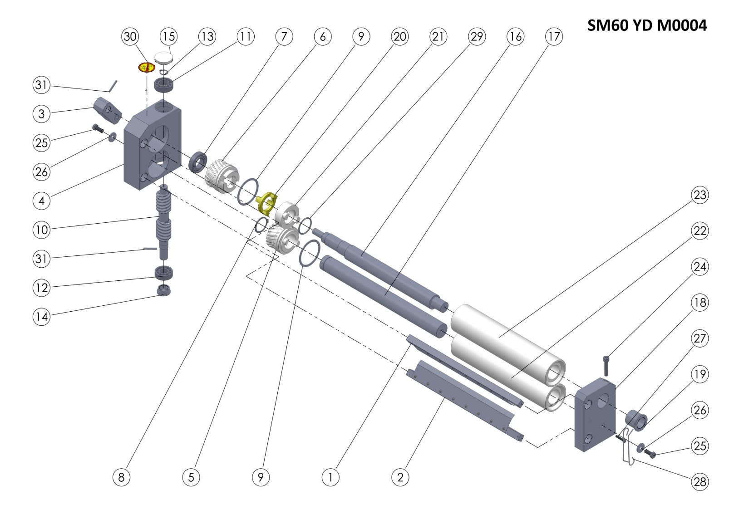
SM60 YD M0004 TOP ROLLER GROUP

SM60 YD M0004 (TOP ROLLER GROUP) SPARE PARTS LIST
ITEM | SPARE PART NUMBER | SPARE PART DESCRIPTION | UNIT |  | ITEM | SPARE PART NUMBER | SPARE PART DESCRIPTION | UNIT
1 | 00351M | ROLLER SCRAPER (TOP) | 1 |  | 17 | 00245 | SHAFT (BOTTOM) | 1
2 | 00352M | ROLLER SCRAPPER (BOTTOM) | 1 |  | 18 | 00202 | ROLLER BEARING | 1
3 | 00348M | ADJUSTING LEVER | 1 |  | 19 | 00222 | THIMBLE | 1
4 | 00203 | GEARBOX | 1 |  | 20 | 00218 | CLUTCH | 1
5 | 00205 | GEAR (MALE) | 1 |  | 21 | 00227 | ROLLER CLUTCH | 1
6 | 00204 | GEAR (FEMALE) | 1 |  | 22 | 00256 | ROLLER (TOP) | 1
7 | 00208 | BEARING | 1 |  | 23 | 00261 | ROLLER (BOTTOM) | 1
8 | 00249 | RING | 1 |  | 24 | 00349 | BOLT | 1
9 | 00228 | GEAR RING | 2 |  | 25 | 00043 | BOLT | 2
10 | 00206 | WORM | 1 |  | 26 | 00044 | WASHER | 2
11 | 00207 | BEARING | 1 |  | 27 | 00266 | BOLT | 1
12 | 00209 | BEARING | 1 |  | 28 | 00267 | SCRAPERS WIRE | 2
13 | 00211 | RING | 1 |  | 29 | 00226 | O-RING | 1
14 | 00210 | THIMBLE | 1 |  | 30 | 00037 | LABEL | 1
15 | 00219 | COVER | 1 |  | 31 | 00096 | PIN | 2
16 | 00240 | SHAFT (TOP) | 1

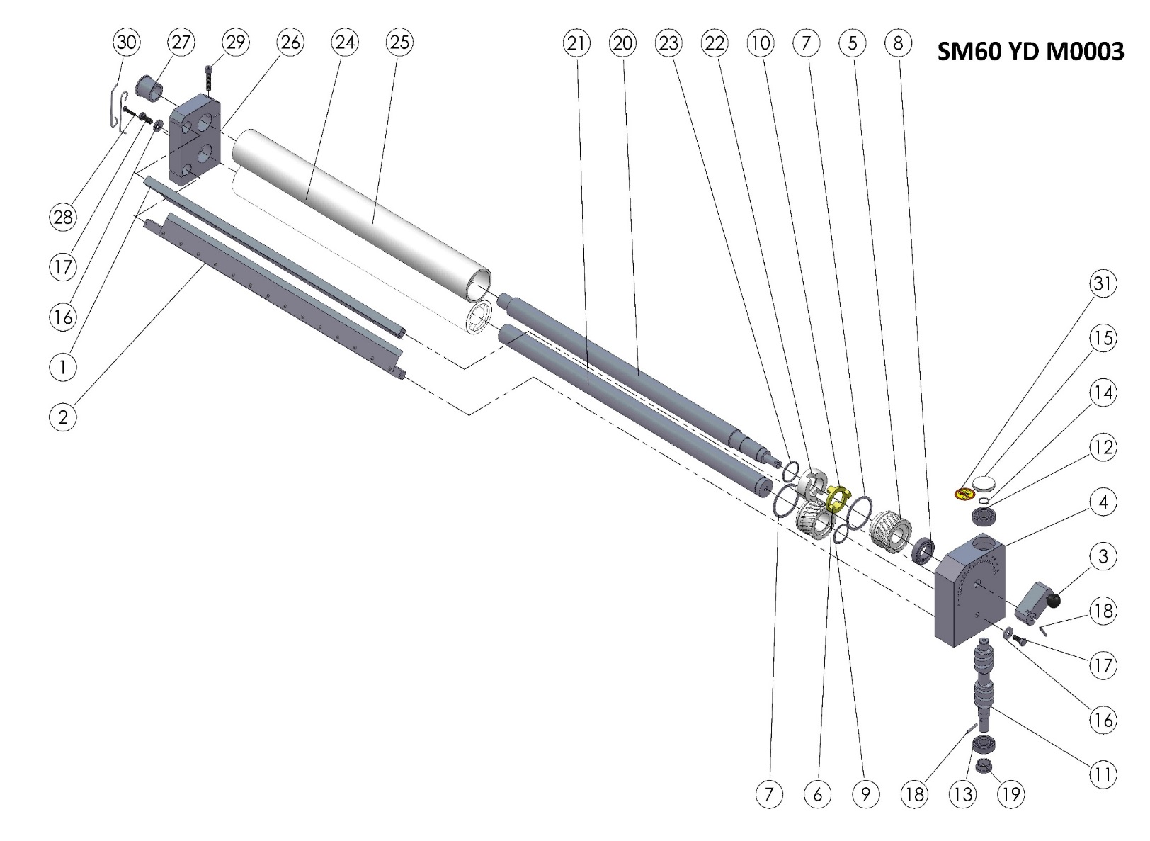

SM60 YD M0003 BOTTOM ROLLER GROUP

SM60 YD M0003 (BOTTOM ROLLER GROUP) SPARE PARTS LIST
ITEM | SPARE PART NUMBER | SPARE PART DESCRIPTION | UNIT |  | ITEM | SPARE PART NUMBER | SPARE PART DESCRIPTION | UNIT
1 | 00353M | ROLLER SCRAPERS (TOP) | 1 |  | 17 | 00043 | BOLT | 2
2 | 00354M | ROLLER SCRAPERS (BOTTOM) | 1 |  | 18 | 00096 | PIN | 2
3 | 00348M | ADJUSTING LEVER | 1 |  | 19 | 00210 | THIMBLE | 1
4 | 00201 | GEARBOX | 1 |  | 20 | 00243 | SHAFT (TOP) | 1
5 | 00204 | GEAR (FEMALE) | 1 |  | 21 | 00248 | SHAFT (BOTTOM) | 1
6 | 00205 | GEAR (MALE) | 1 |  | 22 | 00227 | ROLLER CLUTCH | 1
7 | 00228 | GEAR RING | 2 |  | 23 | 00226 | O-RING | 1
8 | 00208 | BEARING | 1 |  | 24 | 00259 | ROLLER (BOTTOM) | 1
9 | 00249 | RING | 1 |  | 25 | 00264 | ROLLER (TOP) | 1
10 | 00218 | CLUTCH | 1 |  | 26 | 00200 | ROLLER BEARING | 1
11 | 00206 | WORM | 1 |  | 27 | 00222 | THIMBLE | 1
12 | 00207 | BEARING | 1 |  | 28 | 00266 | BOLT | 1
13 | 00209 | BEARING | 1 |  | 29 | 00349 | BOLT | 1
14 | 00211 | RING | 1 |  | 30 | 00267 | SCRAPERS WIRE | 2
15 | 00219 | COVER | 1 |  | 31 | 00037 | LABEL | 1
16 | 00044 | WASHER | 2

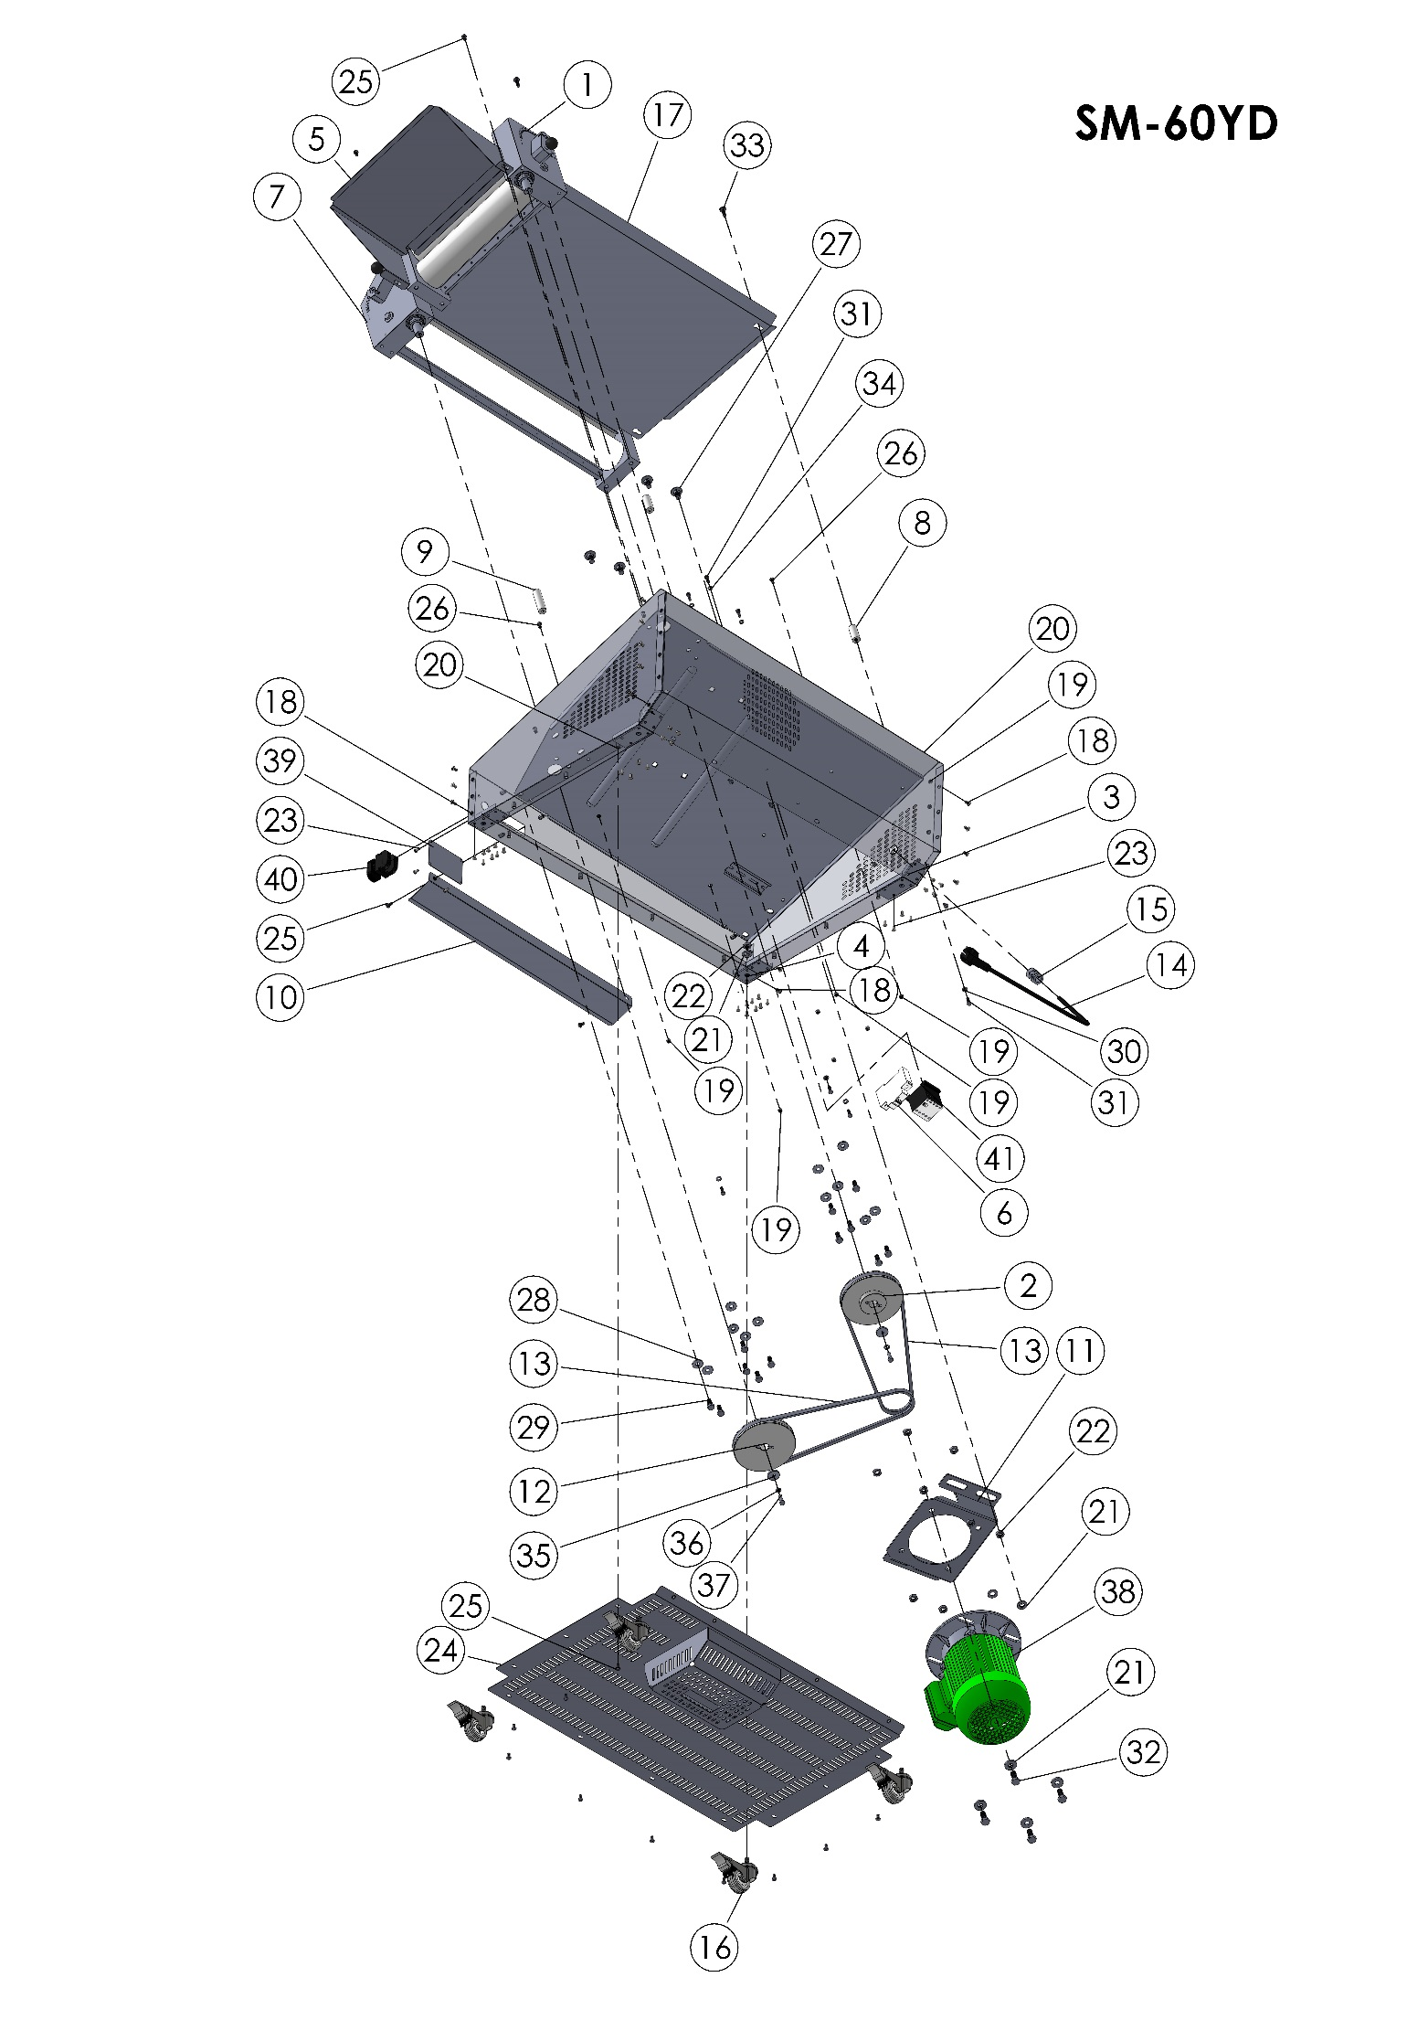
SM60 YD BODY

ITEM | SPARE PART NUMBER | SPARE PART DESCRIPTION | UNIT |  | ITEM | SPARE PART NUMBER | SPARE PART DESCRIPTION | UNIT
1 | SM60 YD M0004 | UPPER ROLLER GROUP (COMPLETE) | 1 |  | 22 | 00298 | NUT | 12
2 | 00213 | V BELT PULLEY | 1 |  | 23 | 01529 | RIVET | 36
3 | 00527 | WHEEL PLATE | 2 |  | 24 | 00199M | BASE PLATE | 1
4 | 00528 | WHEEL PLATE | 2 |  | 25 | 00278 | BOLT | 18
5 | 00523 | FEEDER PLATE | 1 |  | 26 | 00048 | 00048 BE BOLT | 4
6 | 00057 | FUSE | 1 |  | 27 | 00499 | BOLT | 4
7 | SM60 YD M0003 | BUTTOM ROLLER GROUP(COMPLETE) | 1 |  | 28 | 00044 | WASHER | 12
8 | 00289 | MIDDLE FEEDER PLATE PIN (SHORT) | 2 |  | 29 | 00043 | BOLT | 12
9 | 00276 | MIDDLE FEEDER PLATE PIN (LONG) | 2 |  | 30 | 00051 | WASHER | 4
10 | 00275 | OUTPUT PLATE | 1 |  | 31 | 00049 | BOLT | 7
11 | 00480 | ENGINE PLATE | 1 |  | 32 | 00279 | BOLT | 4
12 | 00212 | PULLEY | 1 |  | 33 | 00291 | BOLT | 4
13 | 00299 | BELT | 2 |  | 34 | 02582 | WASHER | 3
14 | 00058 | ELECTRIC CABLE | 1 |  | 35 | 00006 | WASHER | 2
15 | 00097 | COUPLİNG | 1 |  | 36 | 00042 | PLAIN WASHER | 2
16 | 00297 | WHEEL | 4 |  | 37 | 00041 | BOLT | 2
17 | 00271 | MIDDLE FEEDER PLATE TERMINAL | 1 |  | 38 | SM60 YD M0001 | ENGINE | 1
18 | 00157 | BOLT | 14 |  | 39 | 00302 | LABEL PLATE | 1
19 | 00052 | NUT | 21 |  | 40 | 00055 | BUTTON | 1
20 | 00202M | BODY | 1 |  | 41 | 00056 | CONTAKTOR | 1
21 | 00277 | WASHER | 12
SM60 YD BODY SPARE PARTS LIS
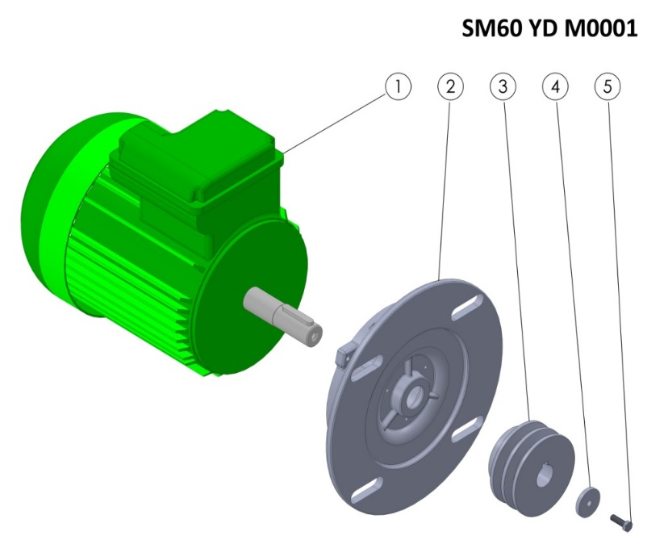
SM60 YD M0001 SPARE PARTS LIST
ITEM | SPARE PART NUMBER | SPARE PART DESCRIPTION | UNIT
1 | 00254 | ENGINE | 1
2 | 00252 | ENGINE FLANGE | 1
3 | 00214 | CASTING V BELT PULLEY | 1
4 | 00098 | PULLEY WASHER | 1
5 | 00049 | BOLT | 1

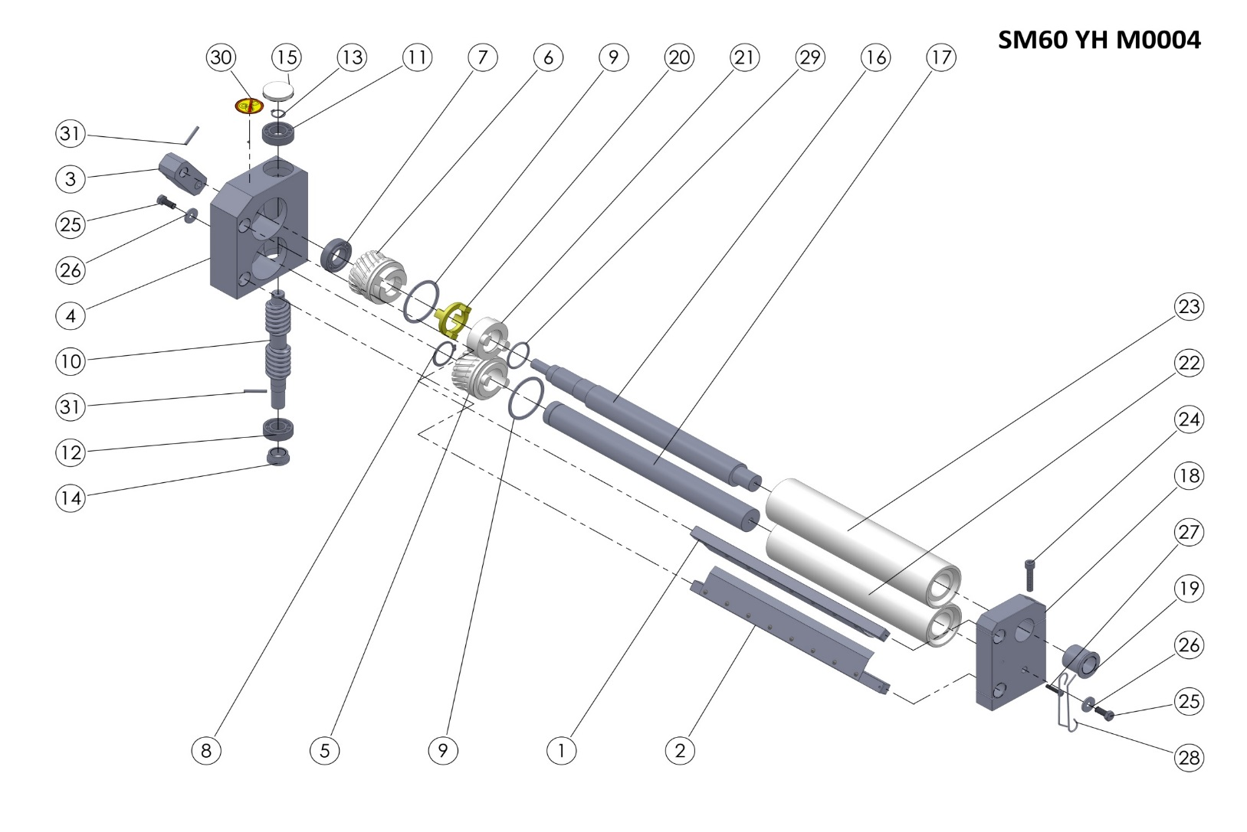
6.4 SM-60 YH Spare Parts Manual:
SM60 YH M0004 TOP ROLLER GROUP

SM60 YH M0004 (TOP ROLLER GROUP) SPARE PARTS LIST
ITEM | SPARE PART NUMBER | SPARE PART DESCRIPTION | UNIT |  | ITEM | SPARE PART NUMBER | SPARE PART DESCRIPTION | UNIT
1 | 00351M | ROLLER SCRAPER (TOP) | 1 |  | 17 | 00245 | ROLLER SHAFT (BOTTOM) | 1
2 | 00352M | ROLLER SCRAPER (ALT) | 1 |  | 18 | 00202 | ROLLER BEARING | 1
3 | 00348M | ADJUSTING HANDLE | 1 |  | 19 | 00222 | THIMBLE | 1
4 | 00203 | GEARBOX | 1 |  | 20 | 00218 | CLUTCH | 1
5 | 00205 | GEAR (MALE) | 1 |  | 21 | 00227 | ROLLER CLUTCH | 1
6 | 00204 | GEAR (FEMALE) | 1 |  | 22 | 00256 | ROLLER (BOTTOM) | 1
7 | 00208 | BEARING | 1 |  | 23 | 00261 | ROLLER (TOP) | 1
8 | 00249 | RING | 1 |  | 24 | 00349 | BOLT | 1
9 | 00228 | GEAR RING | 2 |  | 25 | 00043 | BOLT | 2
10 | 00206 | WORM | 1 |  | 26 | 00044 | WASHER | 2
11 | 00207 | GEARING | 1 |  | 27 | 00266 | BOLT | 1
12 | 00209 | GEARING | 1 |  | 28 | 00267 | SCRAPERS WIRE | 2
13 | 00211 | RING | 1 |  | 29 | 00226 | O-RING | 1
14 | 00210 | THIMBLE | 1 |  | 30 | 00037 | LABEL | 1
15 | 00219 | COVER | 1 |  | 31 | 00096 | PIN | 2
16 | 00240 | ROLLER SHAFT (TOP) | 1

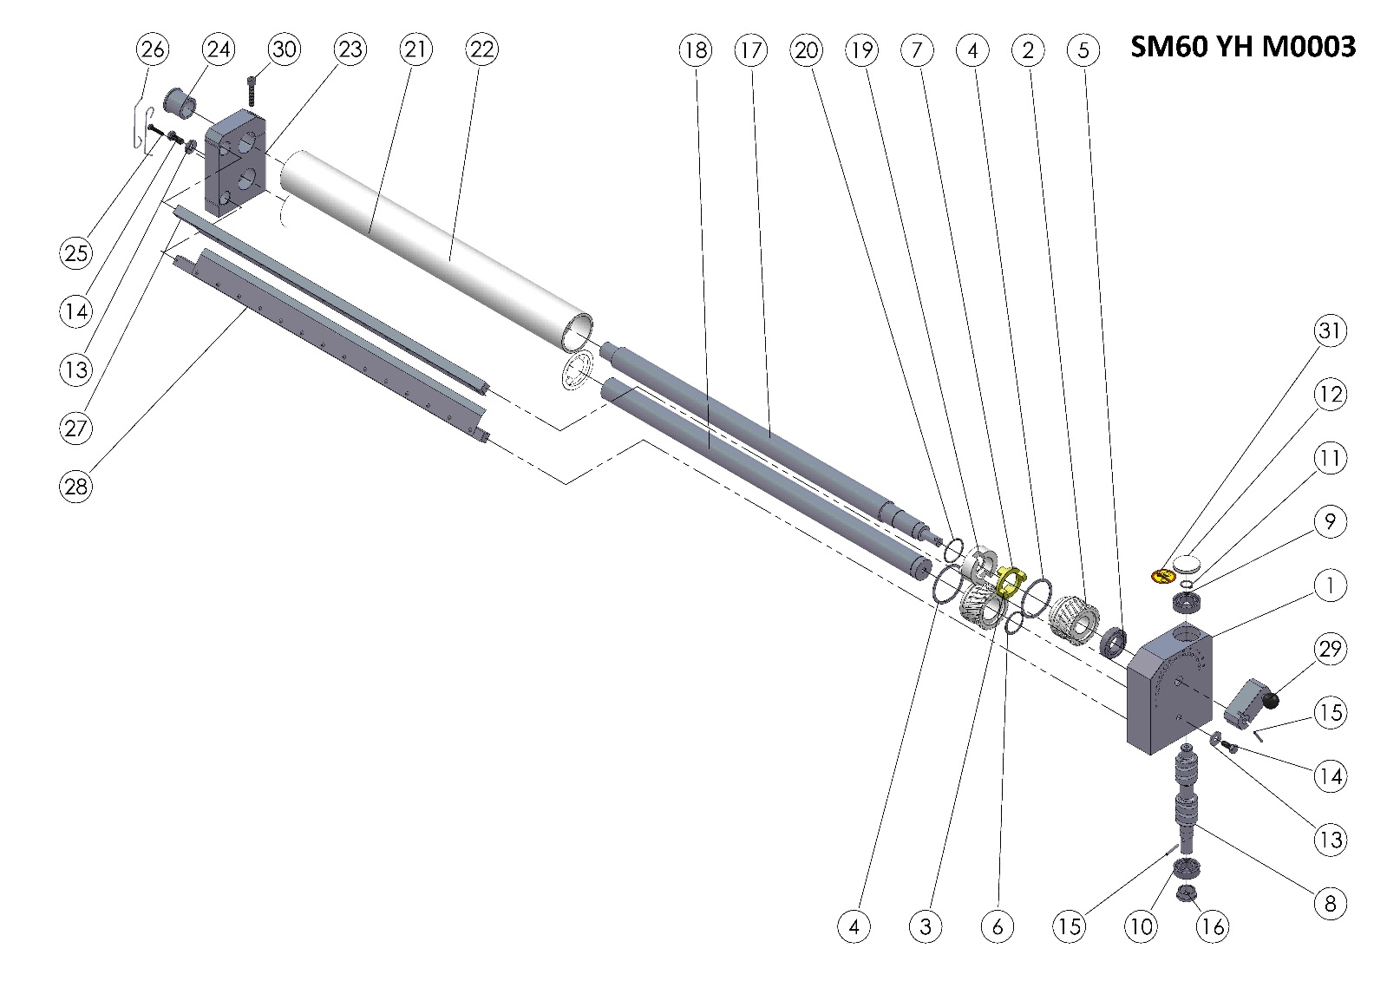

SM60 YH M0003 BOTTOM ROLLER GROUP

SM60 YH M0003 (BOTTOM ROLLER GROUP) SPARE PARTS LIST
ITEM | SPARE PART NUMBER | SPARE PART DESCRIPTION | UNIT |  | ITEM | SPARE PART NUMBER | SPARE PART DESCRIPTION | UNIT
1 | 00201 | GEARBOX | 1 |  | 17 | 00243 | ROLLER SHAFT (TOP) | 1
2 | 00204 | GEAR (FEMALE) | 1 |  | 18 | 00248 | ROLLER SHAFT (BOTTOM) | 1
3 | 00205 | GEAR (MALE) | 1 |  | 19 | 00227 | ROLLER CLUTCH | 1
4 | 00228 | GEAR RING | 2 |  | 20 | 00226 | O-RING | 1
5 | 00208 | BEARING | 1 |  | 21 | 00259 | ROLLER (BOTTOM) | 1
6 | 00249 | RING | 1 |  | 22 | 00264 | ROLLER (TOP) | 1
7 | 00218 | CLUTCH | 1 |  | 23 | 00200 | ROLLER BEARING | 1
8 | 00206 | WORM | 1 |  | 24 | 00222 | THIMBLE | 1
9 | 00207 | BEARING | 1 |  | 25 | 00266 | BOLT | 1
10 | 00209 | BEARING | 1 |  | 26 | 00267 | SCRAPERS WIRE | 2
11 | 00211 | RING | 1 |  | 27 | 00353M | ROLLER SCRAPER (TOP) | 1
12 | 00219 | KAPAK | 1 |  | 28 | 00354M | ROLLER SCRAPER (BOTTOM) | 1
13 | 00044 | WASHER | 2 |  | 29 | 00348M | ADJUSTING LEVER | 1
14 | 00043 | BOLT | 2 |  | 30 | 00349 | BOLT | 1
15 | 00096 | PIN | 2 |  | 31 | 00037 | LABEL | 1
16 | 00210 | THIMBLE | 1

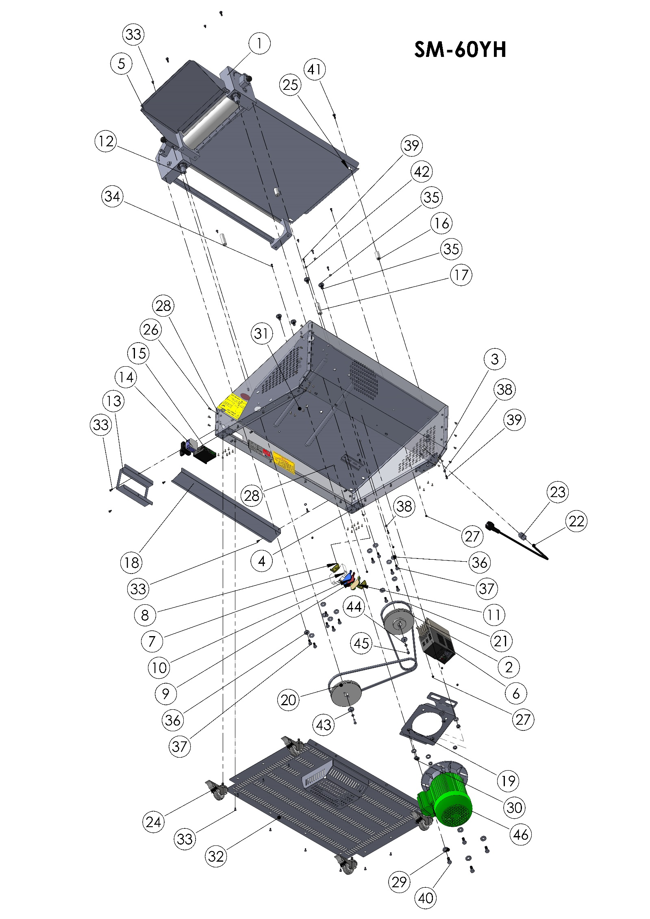
SM60 YH BODY

ITEM | SPARE PART NUMBER | SPARE PART DESCRIPTION | UNIT |  | ITEM | SPARE PART NUMBER | SPARE PART DESCRIPTION | UNIT
1 | SM60 YD M0004 | UPPER ROLLER GROUP (COMPLETE) | 1 |  | 24 | 00297 | WHEEL | 4
2 | 00213 | V BELT PULLEY | 1 |  | 25 | 00271 | MIDDLE FEEDER PLATE | 1
3 | 00527 | WHEE PLATE | 2 |  | 26 | 00157 | BOLT | 14
4 | 00528 | WHEEL PLATE | 2 |  | 27 | 00052 | NUT | 21
5 | 00523 | FEEDER PLATE | 1 |  | 28 | 00202M | BODY | 1
6 | 00384 | SPEED CONTROL | 1 |  | 29 | 00277 | WASHER | 12
7 | 00057 | FUSE | 1 |  | 30 | 00298 | NUT | 12
8 | 00292 | LIMITER | 2 |  | 31 | 01529 | RIVET | 32
9 | 00295 | CONNECTOR | 1 |  | 32 | 00199M | BASE PLATE | 1
10 | 00294 | CONNECTOR (BLUE) | 1 |  | 33 | 00278 | BOLT | 20
11 | 00293 | CONNECTOR (GROUNDING) | 1 |  | 34 | 00048 | 00048 BE BOLT | 4
12 | SM60 YH M0007 | ROLLER (COMPLETE) | 1 |  | 35 | 00499 | BOLT | 4
13 | 00522 | SWITCH PROTECTION VALVE | 1 |  | 36 | 00044 | WASHER | 12
14 | 00224 | ON / OFF SWITCH | 1 |  | 37 | 00043 | BOLT | 12
15 | 00250 | POTENTIOMETER | 1 |  | 38 | 00051 | WASHER | 4
16 | 00289 | MIDDLE FEEDER PLATE PIN (SHORT) | 2 |  | 39 | 00049 | BOLT | 7
17 | 00276 | MIDDLE FEEDER PLATE PIN | 2 |  | 40 | 00279 | BOLT | 4
18 | 00275 | OUTPUT PLATE | 1 |  | 41 | 00291 | BOLT | 4
19 | 00480 | ENGINE PLATE | 1 |  | 42 | 02582 | WASHER | 3
20 | 00212 | PULLEY | 1 |  | 43 | 00006 | WASHER | 2
21 | 00299 | BELT | 2 |  | 44 | 00042 | PLAIN WASHER M6 | 2
22 | 00058 | ELECTRİC CABLE | 1 |  | 45 | 00041 | BOLT | 2
23 | 00097 | COUPLİNG | 1 |  | 46 | SM60 YH M0001 | ENGINE (WITH FLANGE) | 1
SM60 YH BODY SPARE PARTS LIST

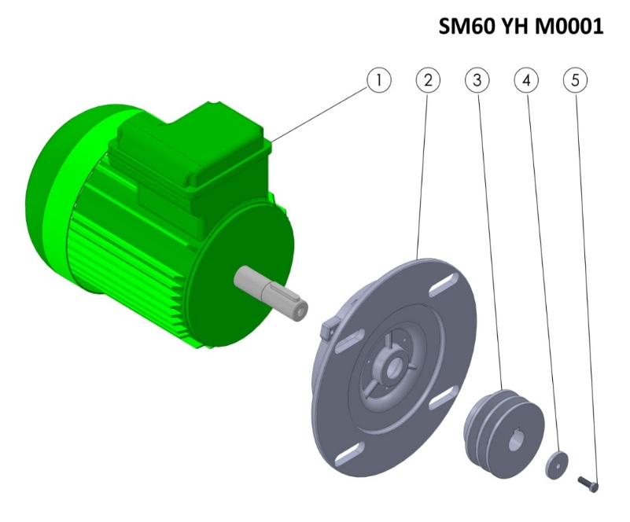

SM60 YH M0001 SPARE PARTS LIST
ITEM | SPARE PART NUMBER | SPARE PART DESCRIPTION | UNIT
1 | 00254 | ENGINE | 1
2 | 00252 | ENGINE FLANGE | 1
3 | 00214 | CASTING V BELT PULLEY | 1
4 | 00098 | WASHER | 1
5 | 00049 | BOLT | 1

SECTION 7: ELECTRICAL DIAGRAM

7.1 SM-55 YD / SM-60 YD Electrical Diagram:

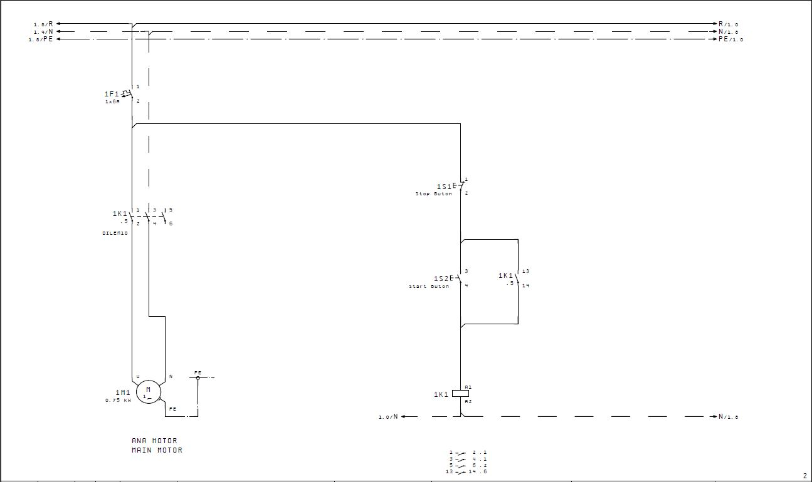

7.2 SM-55 YH / SM-60 YH Electrical Diagram:

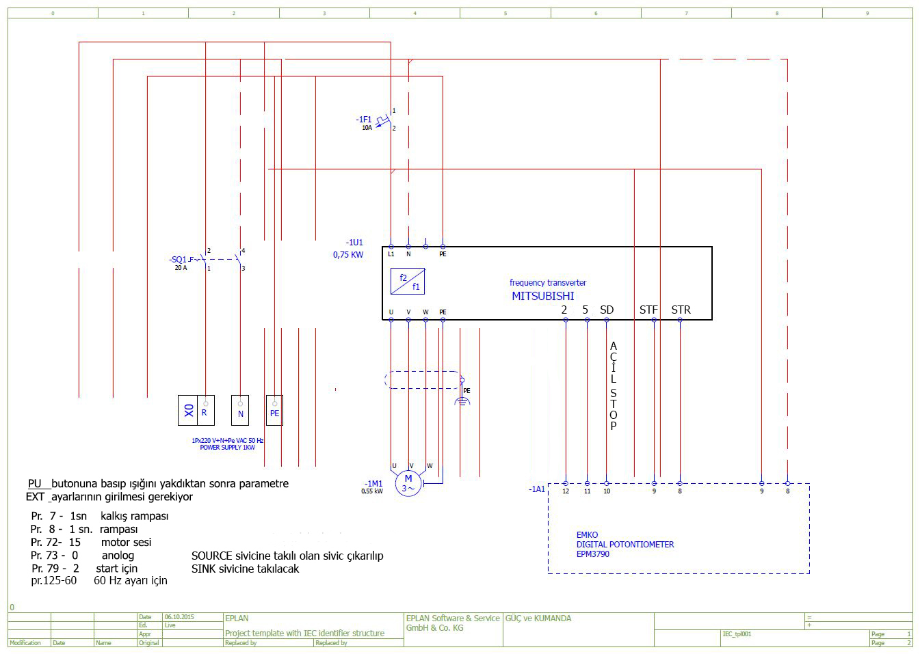

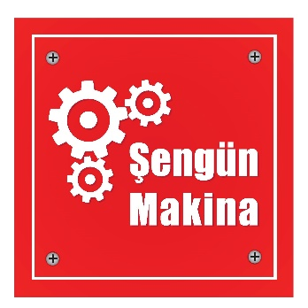

ŞENGÜN MAKİNA İNŞAAT VE KIRTASİYE SAN. TİC. LTD. ŞTİ.
İkitelli Organize Sanayi Bölgesi, Atatürk Bulvarı, Pufa İş Merkezi No: 98 Bodrum Kat: 2-3
Başakşehir/ İstanbul/ Türkiye

Phone: +90 212 671 23 23 (Pbx)
Phone 2: +90 212 671 84 84
Fax: +90 212 671 88 28
GSM: +90 533 957 14 53

e-Mail : info@sengunmakina.com
web : www.sengunmakina.com

