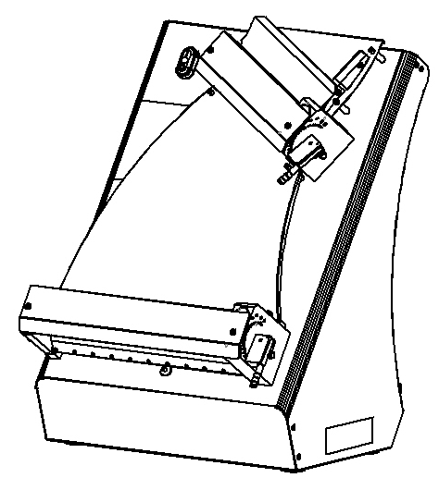

HX-30H/40H, HX-30DH/40DH
DOUGH ROLLING MACHINE

USER & MAINTENANCE MANUAL

WARRANTY CERTIFICATE
SERIAL NUMBER:
SALE DATE:
Sold at the above date HX- ….. DOUGH ROLLING MACHINE is guaranteed against production failures for ..… Year by manufacturer.

Warranty Terms;
- Warranty terms start after the product delivery for ….. year.
- Recommended daily working time is 10 hours. The scope of warranty is assessed by year or by working hours.
- The product is under warranty except plastic rollers (included plastic rollers if it is a manufacturing defect).
- Documents are invalid, if haven’t sale date and confirm signature of company. You have to show the warranty certificate to benefit from the warranty.
- Device is guaranteed against defects if mount and use as described in the use and maintenance manual.
- Detection the location of defects, and elimination of the problems are responsibilities of the manufacturer.
- Warranty terms include only one device. You can’t claim any rights or compensation for another device.
- If Changes are made at the type, model and serial numbers, the warranty eliminates.
- If material, worker or assembly defects appear, repaired free by manufacturer at the product warranty period (Transportation cost is not included).
- Failures are only repaired by manufacturer personal. The intervention of unauthorized person cancel the appliance of warranty.
- Installation have to be done by manufacturer personal. İf usage place changes, customer must give information to manufacturer
- In the event of failure service must be informed.
- The failures and damages given by external factors are out of the warranty terms.
- Any failure of the product warranty period is added to the product warranty time. The repair time is until 20 working days.
AUTHORIZED PERSON
STAMP –SIGNATURE

PRESENTATION

- Please read the manuel carefully before installing the machine.
- The machine will be out of warranty when your operate the machine with at read.
- Please read carefully the manual that gives you information on the installation is prepared in accordance with the legal regulations before arriving at the machine installation.
- For information you coonot understand, ask your nearest out horized service
- Please note that if the technical service personnel is kept waiting you will be billed for each hour.

CONTENTS
WARRANTY CERTIFICATE

PRESANTATION

SECTION 1: INTRODUCTION
1.1 General Introduction of Dough Rolling Machine Model: HX-30H/40H, HX-30DH/40DH
1.2 Technical Specifications Table
1.3 Safety Warnings Labels

SECTION 2: INTRODUCTION OF MACHINE BODY COMPONENTS

2.1 Body Components

SECTION 3: INSTRUCTIONS FOR USE
3.1 Usage Recommendations
3.2 Safety Warnings
3.3 Operating and Starting Instructions
3.4 Operation On Optional Pedal Models
SECTION 4: MAINTENANCE
4.1 Exterior Body Maintenance
4.2 Scraping Knife Maintenance

SECTION 5: MACHINE SPARE PARTS MANUAL

SECTION 6: ROLLER PROTECTION SHEET ASSEMBLY

SECTION 7: ELECTRICAL DIAGRAM
7.1 HX-30H/40H, HX-30DH/40DH Electrical Diagram
7.2 HX-30H/40H Pedal, HX-30DH/40DH Flat Pedal Electrical Diagram

SECTION 1: INTRODUCTION
  - General Introduction of Dough Rolling Machine HX-30H /30DH, HX-40H/40DH :

Uses at lahmacun, pizza and other dough rolling processes. Dough thickness and diameter get easy with roller gap adjustment system. Dough rolling process perform in min. 3, max. 5 seconds with fast and easy using feature.

  - Technical Specifications Table:

Technical Specifications Table | HX-30H | HX-30DH | HX-40H | HX-40DH
Machine Length (cm) | 44 | 44 | 43 | 43
Machine Width (cm) | 42 | 42 | 53 | 53
Machine Height (cm) | 62 | 66 | 74 | 77
Machine Weight (Kg) | 31,8 | 31,8 | 39 | 39
Engine Power (kW) | 0.37 | 0.37 | 0.37 | 0.37
Electrical Connection (V-HZ) | 230 1N – 50/60 | 230 1N – 50/60 | 230 1N – 50/60 | 230 1N- 50/60
Dough Weight (gr) | 80-210 | 80-210 | 80-500 | 80-500
Dough Diameter (cm) | 19-29 | 19-29 | 26-40 | 26-40
Roller Range (mm) | 0-4,1 | 0-4,1 | 0-4,1 | 0-4,1
Hourly Production Quantity | 720-1200 | 720-1200 | 720-1200 | 720-1200

1.3 Safety Warnings Labels:

LABELS
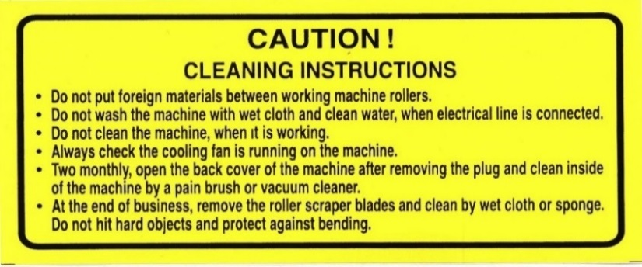

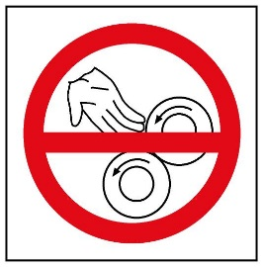

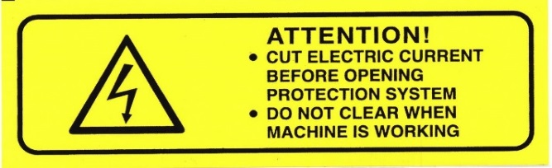

SECTION 2: INTRODUCTION OF MACHINE BODY COMPONENTS

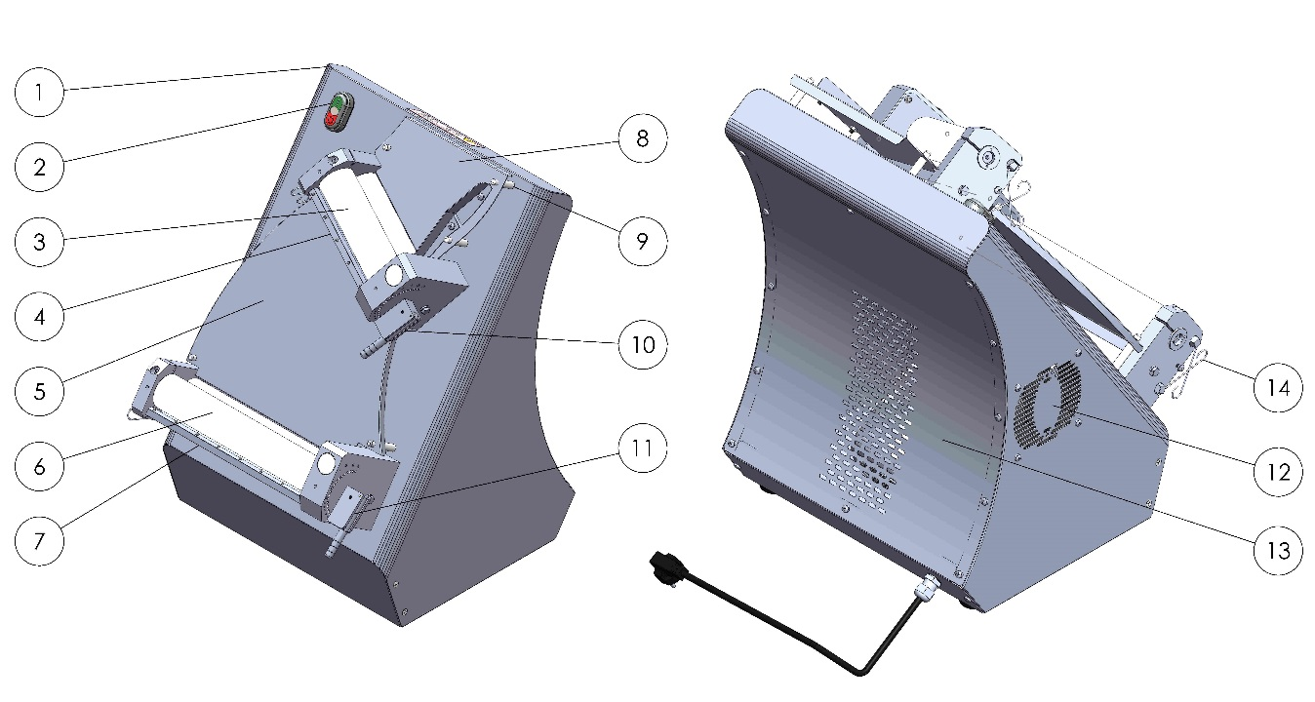
2.1 Body Components:

PART DESCRIPTION
FRONT VIEW |  | BACK VIEW
1 | BODY | 8 | TOP ROAD SHEET
2 | START/STOP SWITCH | 9 | SHEET HOLDER PIN
3 | TOP ROLLER GROUP | 10 | TOP ROLLER RANGE ADJUSTMENT HANDLE
4 | TOP ROLLER SCRAPERS | 11 | UNDER ROLLER RANGE ADJUSTMENT HANDLE
5 | MIDDLE ROAD SHEET | 12 | VENTILATION FAN
6 | BOTTOM ROLER GROUP | 13 | BACK COVER
7 | BOTTOM ROLER SCRAPERS | 14 | ROLLER SCRAPERS WİRE

SECTION 3: INSTRUCTIONS FOR USE

3.1 Usage Recommendations:

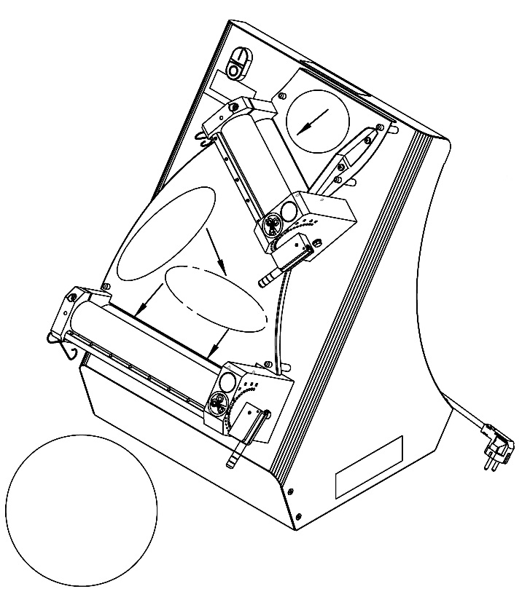
For Rolling Circular Dough (Lahmacun Dough Etc.);

- Compress the dough and make it circular.
- Pass through the dough to the upper roller gap.

Rotate the dough (shown in figure) then pass through the dough in parallel to the bottom roller gap.

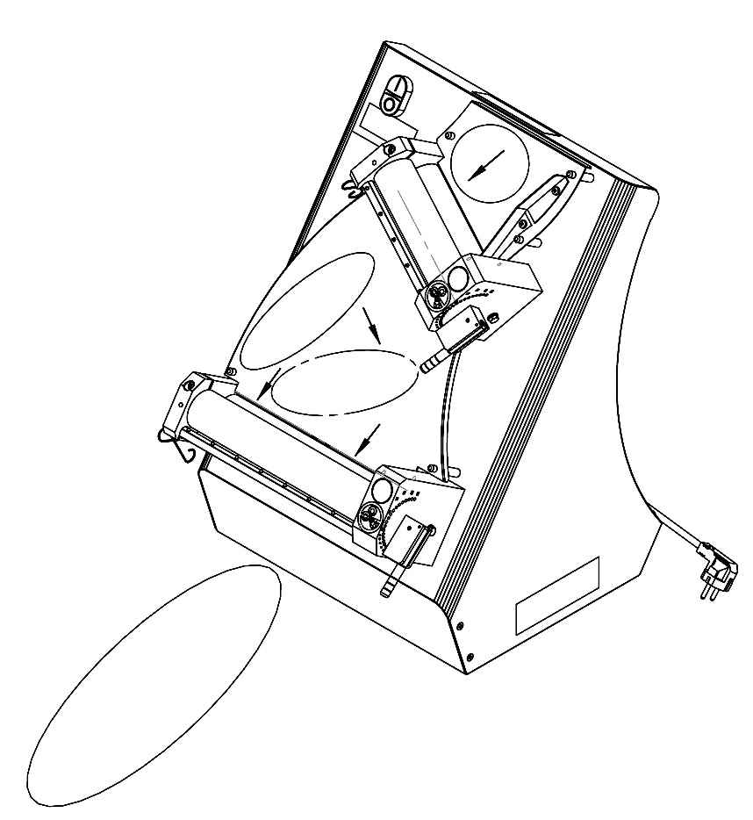
For Rolling Ellipse Dough (Pide Dough);

- Compress the dough and make it circular.
- Pass through the dough to the upper roller gap.
- Rotate the dough (shown in figure) then pass through the dough in 45° to the bottom roller gap.

3.2 Safety Warnings:

- Secure voltage is between 230 V and 240 V
- Set up on a straight floor.
- Single phase on operating.
- Don’t wipe the machine with a wet cloth when connect to plug.
- Cut electric current before opening protection system.
- Check the air intake of the cooling fan daily.

3.3 Operating and Starting Instructions:
- Connect to monophase electrical supply.
- Push the “1” button.
- Adjust the roller space shown in picture. (This procedure adjusts the dough thickness and diameter)
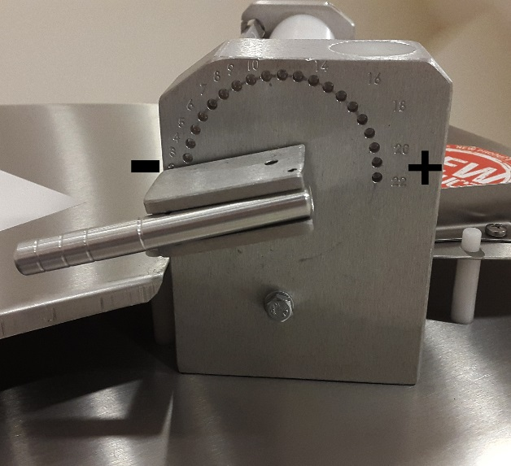
Adjust the dough thickness from “0” to “20” shown in figure.

- Pull the adjustment handle and rotate the handle to “+” or “-” direction.
- Rotate the handle to “+” direction for enlarge the dough thickness. Rotate the handle to “-” direction for reduce the dough thickness.
- Push the adjustment handle when the intended roller gap adjusted.

NOTE = Entrance roller gap advice to be bigger than the exit roller gap.

DESIRED PRODUCT | UPPER | BOTTOM
LAHMACUN
PİDE
PİZZA
NAIL PIDE
TORTILLA BREAD
BOREK DOUGH

NOTE: Write down the values of the input and output (upper and lower) roller adjustment lever which are specified by the user in the table.
NOTE: For roller scrapers to work properly, scraper springs need to be stretched.

3.4 Operation On Optional Pedal Models:

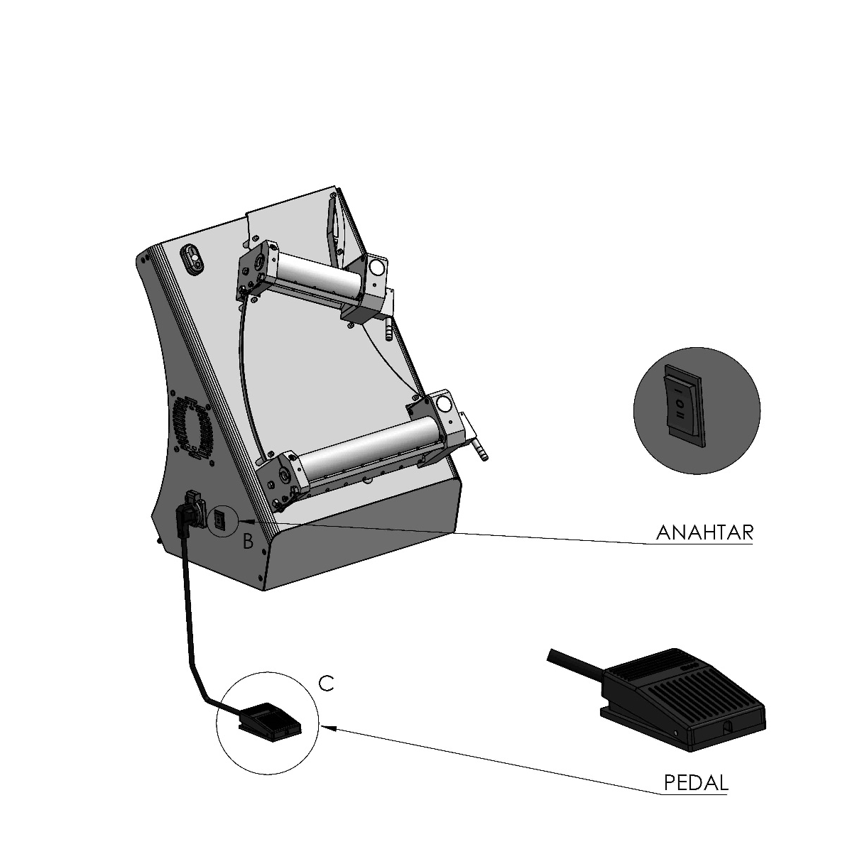
SWITCH

- Plug in the Pedal.

- If you turn switch as “0”, the rolling machine doesn’t work.

- If you turn switch as “I”, you can control the machine with the 0-I switch at the top of Rolling machine.

- If you turn switch as “II” you can control the machine with the pedal. If you press the pedal once, machine works, if you press again machine stops.

- If you don’t want to use pedal unplug the pedal and turn switch as “I” position.

SECTION 4: MAINTENANCE

4.1 Exterior Body Maintenance:
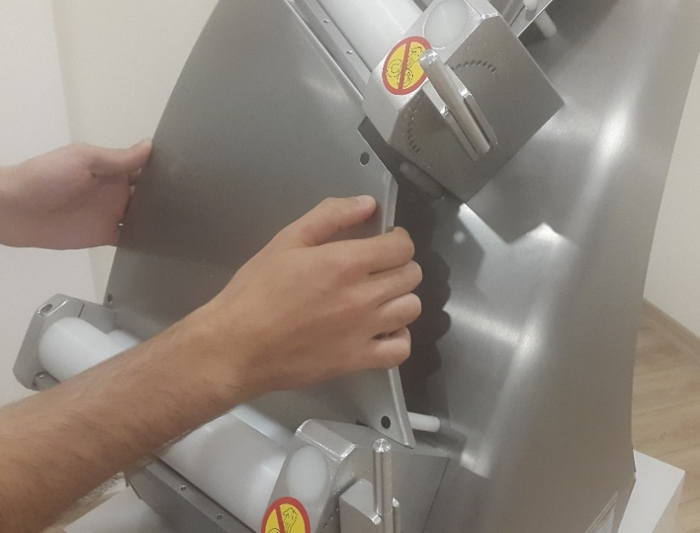
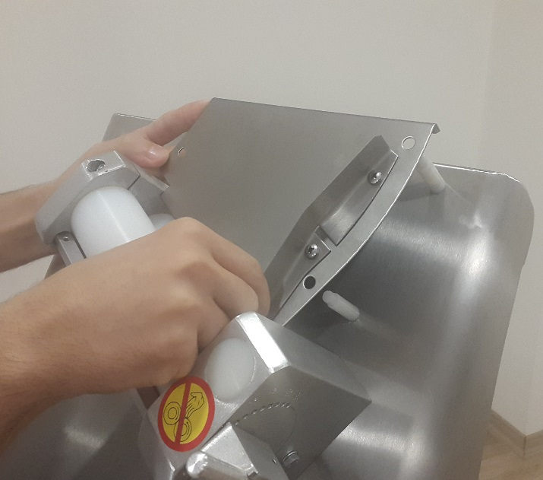

Pull up the entrance and central sheets shown in picture then clean the flour and crumbs. Stop the machine and unplug the electrical supply then clean with wet cloth. Don’t plug the electrical supply before the machine dry.
NOTE: The pins on the road sheet are inserted into their slots on the body and assembled. Pins must be free.

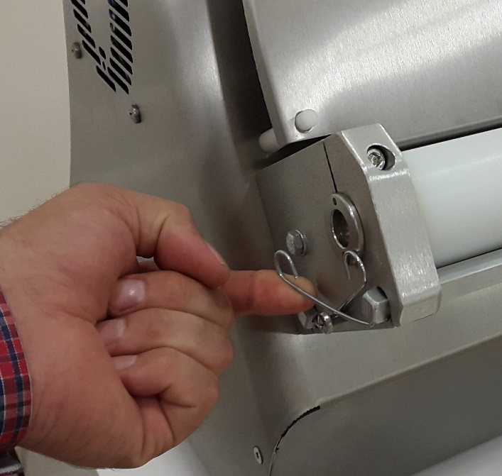
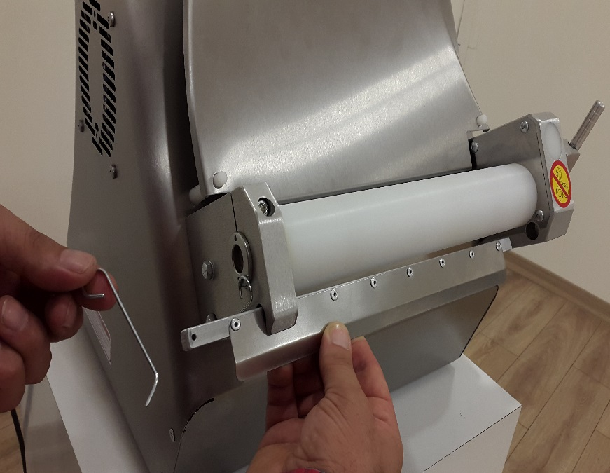
4.2 Scrapers Maintenance:

- Push up scrapers wire as shown in the figure
- Remove the scrapers from the hole as shown in the figure and clean the scrapers daily.

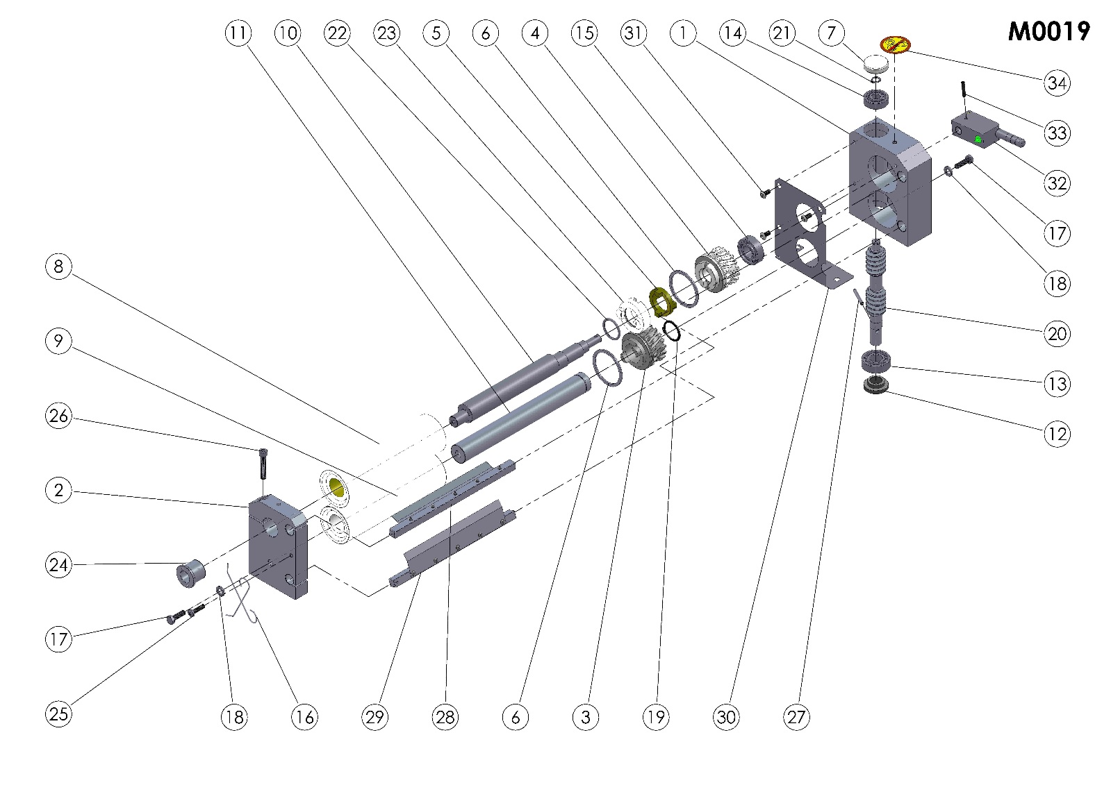
SECTION 5: MACHINE SPARE PARTS MANUAL

ITEM NO. | SPARE PART NUMBER | DESCRIPTION OF THE SPARE PART | UNIT |  | ITEM NO. | SPARE PART NUMBER | DESCRIPTION OF THE SPARE PART | UNIT
1 | 00372 | GEAR BOX | 1 |  | 18 | 00050 | WASHER | 2
2 | 00001 | ROLLER BEARING | 1 |  | 19 | 00089 | RING | 1
3 | 00338 | GEAR | 1 |  | 20 | 00011 | WORM | 1
4 | 00007 | GEAR | 1 |  | 21 | 00027 | RING | 1
5 | 00010 | CLUTCH | 1 |  | 22 | 00092 | O-RING | 1
6 | 00009 | RING | 2 |  | 23 | 00088 | CLUTCH | 1
7 | 00013 | COVER | 1 |  | 24 | 00086 | ADJUST THIMBLE | 1
8 | 00014 | ROLLER | 1 |  | 25 | 00047 | BOLT | 1
9 | 00015 | ROLLER | 1 |  | 26 | 00054 | BOLT | 1
10 | 00018 | SHAFT | 1 |  | 27 | 00096 | PIN | 1
11 | 00019 | SHAFT | 1 |  | 28 | 00333M | ROLLER SCRAPERS (TOP) | 1
12 | 00022 | THIMBLE | 1 |  | 29 | 00334M | ROLLER SCRAPERS (BOTTOM) | 1
13 | 00024 | BEARING | 1 |  | 30 | 00385 | ROLLER GUARD SHEET | 1
14 | 00025 | BEARING | 1 |  | 31 | 00340 | BOLT | 3
15 | 00026 | BEARING | 1 |  | 32 | 00056M | ADJUST THIMBLE | 1
16 | 00038 | SPRING | 2 |  | 33 | 00095 | PIN | 1
17 | 00041 | BOLT | 2 |  | 34 | 00037 | LABEL | 1
HX-30H/HX-30DH M0019 (TOP ROLLER GROUP) SPARE PARTS LIST

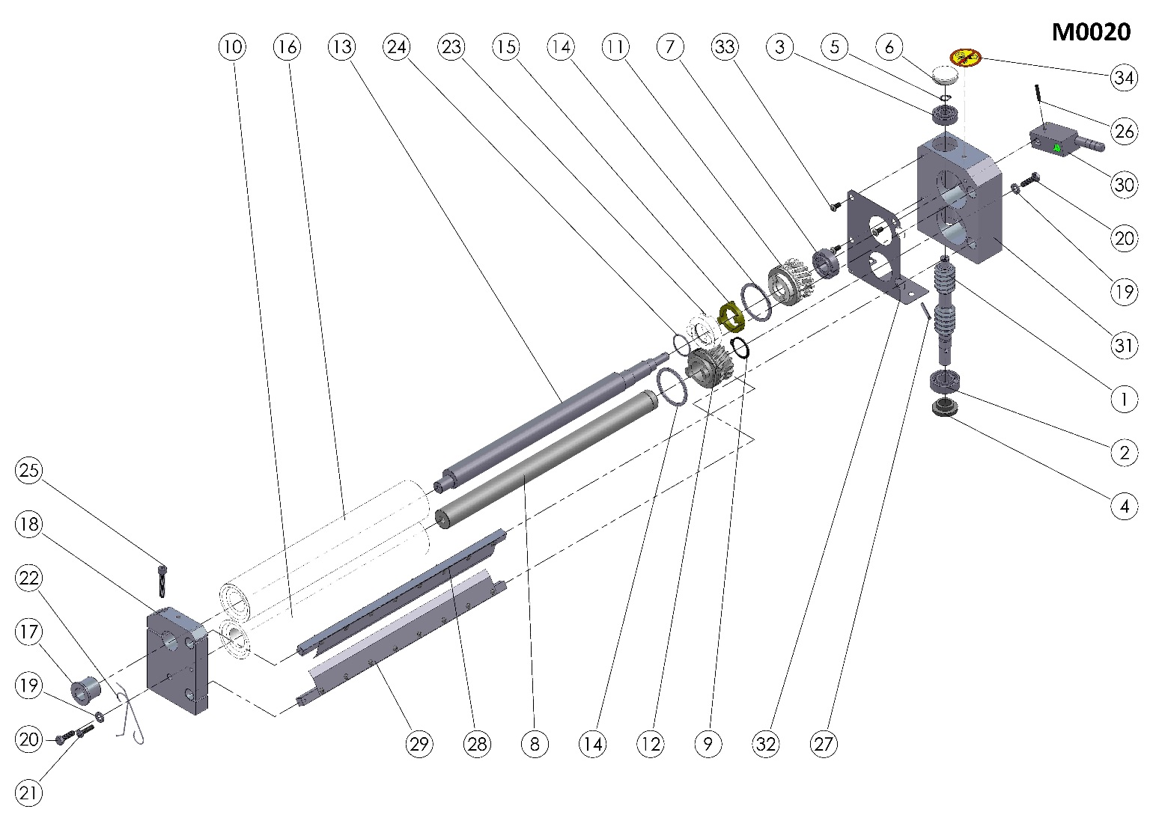

ITEM | SPARE PART NUMBER | DESCRIPTION OF THE SPARE PART | UNIT |  | ITEM | SPARE PART NUMBER | DESCRIPTION OF THE SPARE PART | UNIT
1 | 00011 | WORM | 1 |  | 18 | 00001 | ROLLER BEARING | 1
2 | 00024 | BEARING | 1 |  | 19 | 00050 | WASHER | 2
3 | 00025 | BEARING | 1 |  | 20 | 00041 | BOLT | 2
4 | 00022 | THIMBLE | 1 |  | 21 | 00047 | BOLT | 1
5 | 00027 | RING | 1 |  | 22 | 00038 | SPRING | 2
6 | 00013 | COVER | 1 |  | 23 | 00088 | CLUTCH | 1
7 | 00026 | BEARING | 1 |  | 24 | 00092 | O-RING | 1
8 | 00021 | SHAFT | 1 |  | 25 | 00054 | BOLT | 1
9 | 00089 | RING | 1 |  | 26 | 00095 | PIN | 1
10 | 00017 | ROLLER | 1 |  | 27 | 00096 | PIN | 1
11 | 00007 | GEAR | 1 |  | 28 | 00336M | ROLLER SCRAPERS (TOP) | 1
12 | 00338 | GEAR | 1 |  | 29 | 00337M | ROLER SCRAPERS (BOTTOM) | 1
13 | 00020 | SHAFT | 1 |  | 30 | 00056M | ADJUST LEVER | 1
14 | 00009 | RING | 2 |  | 31 | 00372 | GEAR BOX | 1
15 | 00010 | CLUTCH | 1 |  | 32 | 00385 | ROLLER GUARD SHEET | 1
16 | 00016 | RING | 1 |  | 33 | 00340 | BOLT | 3
17 | 00086 | ADJUST THIMBLE | 1 |  | 34 | 00037 | LABEL | 1
HX-30H/HX-30DH M0020 (BOTTOM ROLLER GROUP) SPARE PART LIST

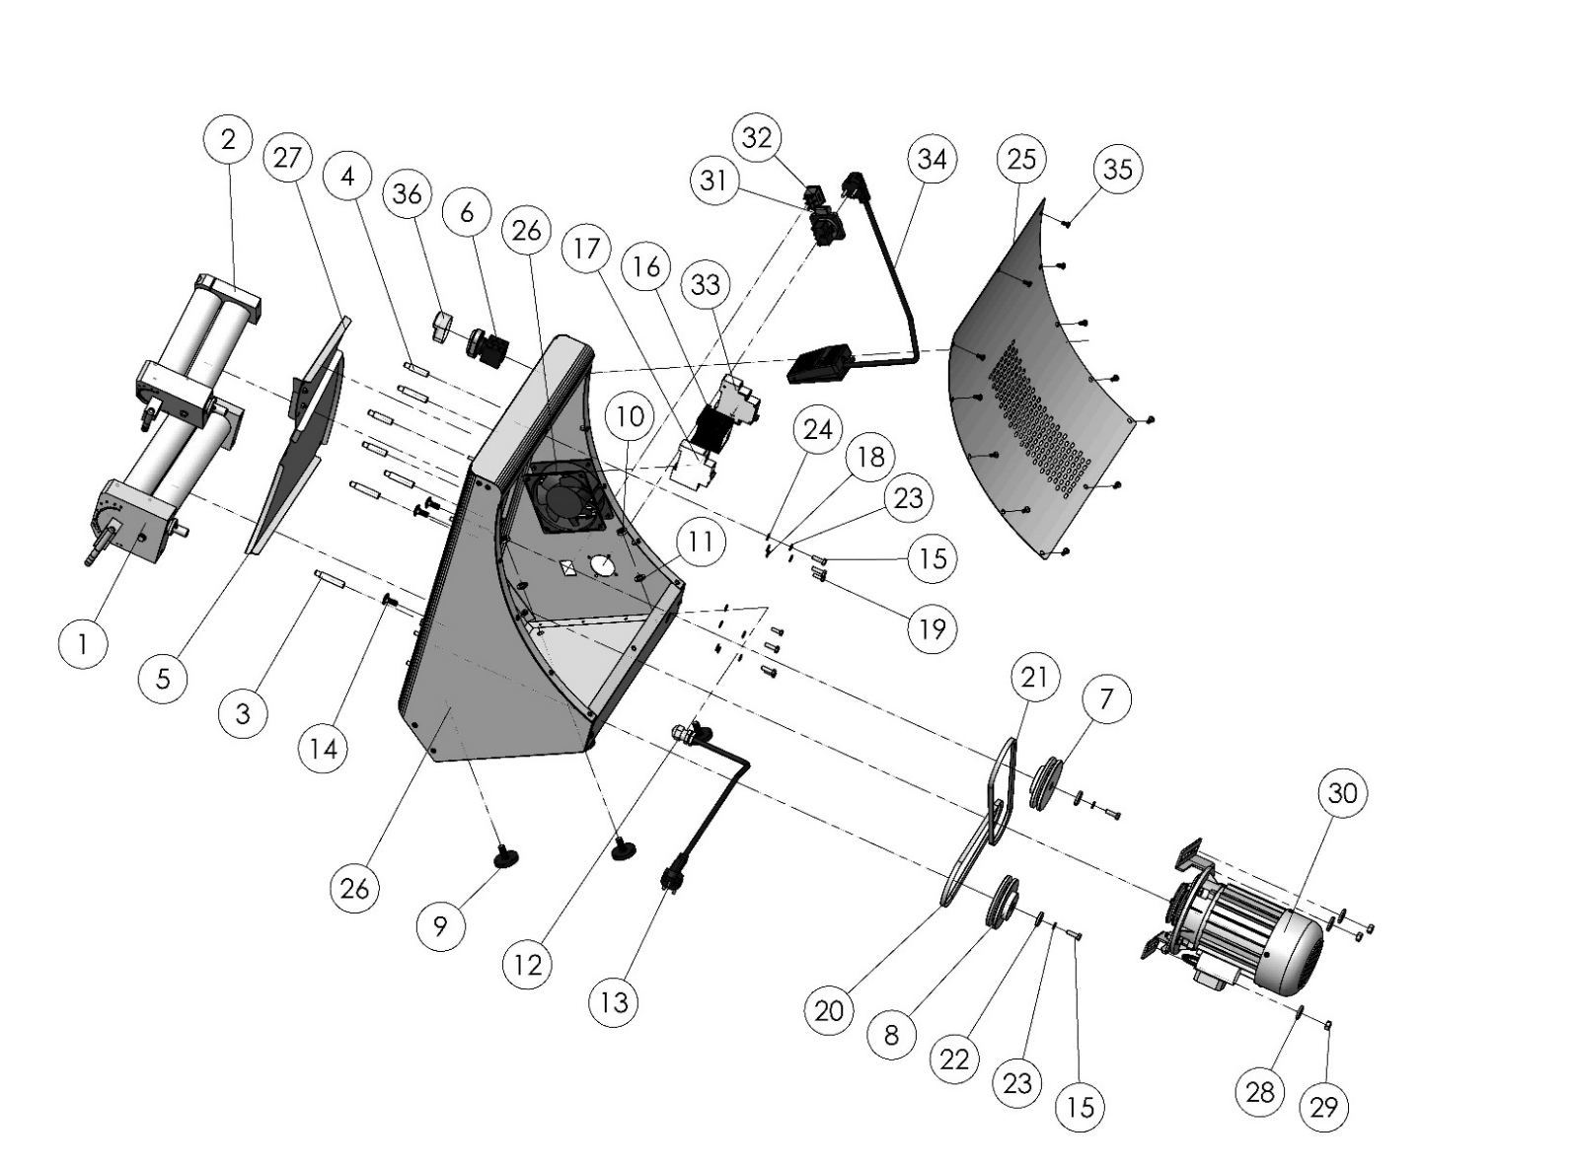
HX-30H /HX-30DH BODY

Optional

HX-30H HX-30DH

NOTE: Parts 31, 32, 33, 34 are optional on all models.

HX-30H /HX- 30DH BODY SPARE PART LIST
ITEM | SPARE PART NUMBER | DESCRIPTION OF THE SPARE PART | UNIT
1 | M0020 | BOTTOM ROLLER (COMPLETE) | 1
2 | M0019 | TOP ROLLER (COMPLETE) | 1
3 | 00132 | MIDDLE ROAD SHEET PIN (LONG) | 4
4 | 00133 | TOP ROAD SHEET PIN (SHORT) | 3
5 | 00345 | MIDDLE ROAD SHEET | 1
6 | 00365 | ON / OFF SWITCH | 1
7 | 00085 | PULLEY | 1
8 | 00005 | PULLEY | 1
9 | 00354 | LEG | 4
10 | 01965 | NUT | 4
11 | 01960 | WASHER | 4
12 | 00097 | RECORD | 1
13 | 00355 | ELECTRIC CABLE | 1
14 | 00476 | BOLT | 3
15 | 00041 | BOLT | 12
16 | 00056 | CONTAKTOR | 1
17 | 00057 | FUSE | 1
18 | 00051 | WASHER | 7
19 | 00049 | BOLT | 7
20 | 00423 | V BELT | 1
21 | 00425 | V BELT | 1
22 | 00006 | WASHER | 2
23 | 00042 | WASHER | 12
24 | 00050 | WASHER | 10
25 | 00342 | BACK COVER | 1
26 | 00036M | BODY | 1
27 | 00360M | TOP ROAD SHEET | 1
28 | 01258 | WASHER | 3
29 | 01959 | NUT | 3
30 | 00058M | ENGINE | 1
31 | 00357 | SOCKET (OPTIONAL) | 1
32 | 00369 | I0II SWITCH (OPTIONAL) | 1
33 | 00367 | CIRCUIT BREAKER (OPTIONAL) | 1
34 | 00034M | PEDAL (OPTIONAL) | 1
35 | 00046 | BOLT | 14
36 | 00620 | BUTTON CASE | 1

ITEM | SPARE PART NUMBER | DESCRIPTION OF THE SPARE PART | UNIT
5 | 00433 | MIDDLE ROAD SHEET | 1
21 | 00427 | V BELT | 1
26 | 00076M | BODY | 1
27 | 00432 | TOP ROAD SHEET | 1
HX-30DH: The Different Parts

00058M SPARE PART LIST
ITEM | SPARE PART NUMBER | DESCRIPTION OF THE SPARE PART | UNIT
1 | 00347 | ENGINE SHEET | 1
2 | 01963 | WASHER | 4
3 | 04072 | BOLT | 4
4 | 01961 | WASHER | 4
5 | 01959 | NUT | 4
6 | 00094 | PULLEY | 1
7 | 00098 | PULLEY WASHER | 1
8 | 00049 | BOLT | 1
9 | 00023 | ENGINE | 1

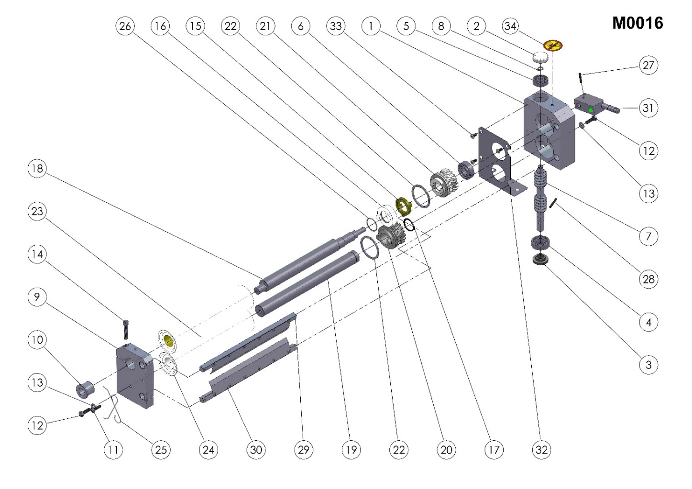

HX-40H/HX-40DH M0016 (TOP ROLLER COMPLETE) SPARE PART LIST
ITEM | SPARE PART NUMBER | DESCRIPTION OF THE SPARE PART | UNIT |  | ITEM | SPARE PART NUMBER | DESCRIPTION OF THE SPARE PART | UNIT
1 | 00372 | GEAR BOX | 1 |  | 18 | 00103 | SHAFT | 1
2 | 00013 | COVER | 1 |  | 19 | 00105 | SHAFT | 1
3 | 00022 | THIMBLE | 1 |  | 20 | 00338 | GEAR | 1
4 | 00024 | BEARING | 1 |  | 21 | 00007 | GEAR | 1
5 | 00025 | BEARING | 1 |  | 22 | 00009 | RING | 2
6 | 00026 | BEARING | 1 |  | 23 | 00134 | ROLLER | 1
7 | 00011 | WORM | 1 |  | 24 | 00135 | ROLLER | 1
8 | 00027 | RING | 1 |  | 25 | 00038 | SPRING | 2
9 | 00001 | ROLLER BEARING | 1 |  | 26 | 00092 | O-RING | 1
10 | 00086 | ADJUST THIMBLE | 1 |  | 27 | 00095 | PIN | 1
11 | 00047 | BOLT | 1 |  | 28 | 00096 | PIN | 1
12 | 00041 | BOLT | 2 |  | 29 | 00339M | TOP ROLLER SCRAPERS (TOP) | 1
13 | 00050 | WASHER | 2 |  | 30 | 00340M | TOP ROLLER SCRAPERS (BOTTOM) | 1
14 | 00054 | BOLT | 1 |  | 31 | 00056M | ADJUST LEVER | 1
15 | 00010 | CLUTCH | 1 |  | 32 | 00385 | ROLLER GUARD SHEET | 1
16 | 00088 | CLUTCH | 1 |  | 33 | 00340 | BOLT | 3
17 | 00089 | RING | 1 |  | 34 | 00037 | LABEL | 1

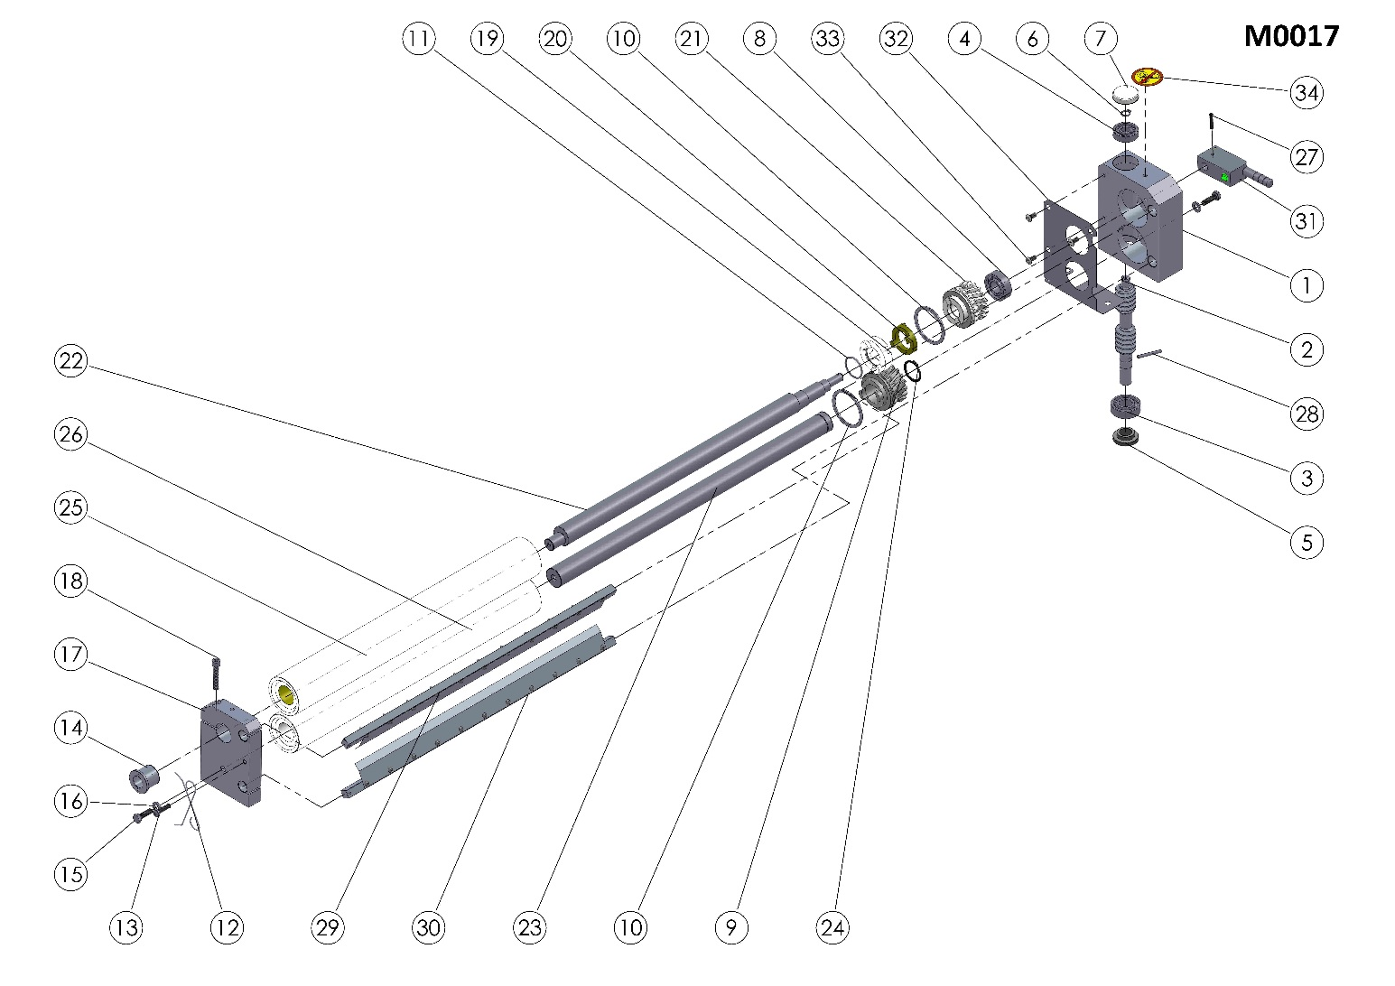

HX-40H/HX-40DH M0017 (BOTTOM ROLLER GROUP) SPARE PARTS LIST
ITEM | SPARE PART NUMBER | DESCRIPTION OF THE SPARE PART | UNIT |  | ITEM | SPARE PART NUMBER | DESCRIPTION OF THE SPARE PART | UNIT
1 | 00372 | GEAR BOX | 1 |  | 18 | 00054 | BOLT | 1
2 | 00011 | WORM | 1 |  | 19 | 00088 | CLUTCH | 1
3 | 00024 | BEARING | 1 |  | 20 | 00010 | CLUTCH | 1
4 | 00025 | BEARING | 1 |  | 21 | 00007 | GEAR | 1
5 | 00022 | THIMBLE | 1 |  | 22 | 00102 | SHAFT | 1
6 | 00027 | RING | 1 |  | 23 | 00104 | SHAFT | 1
7 | 00013 | COVER | 1 |  | 24 | 00089 | RING | 1
8 | 00026 | RING | 1 |  | 25 | 00136 | ROLLER | 1
9 | 00338 | GEAR | 1 |  | 26 | 00137 | ROLLER | 1
10 | 00009 | RING | 2 |  | 27 | 00095 | PIN | 1
11 | 00092 | O-RING | 1 |  | 28 | 00096 | PIN | 1
12 | 00038 | SPRING | 2 |  | 29 | 00341M | BOTTOM ROLLER SCRAPERS (TOP) | 1
13 | 00047 | BOLT | 1 |  | 30 | 00342M | BOTTOM ROLLER SCRAPERS (BOTTOM) | 1
14 | 00086 | ADJUST THIMBLE | 1 |  | 31 | 00056M | ADJUST LEVER | 1
15 | 00041 | BOLT | 2 |  | 32 | 00385 | ROLLER GUARD SHEET | 1
16 | 00050 | WASHER | 2 |  | 33 | 00340 | BOLT | 3
17 | 00001 | ROLLER BEARING | 1 |  | 34 | 00037 | LABEL | 1

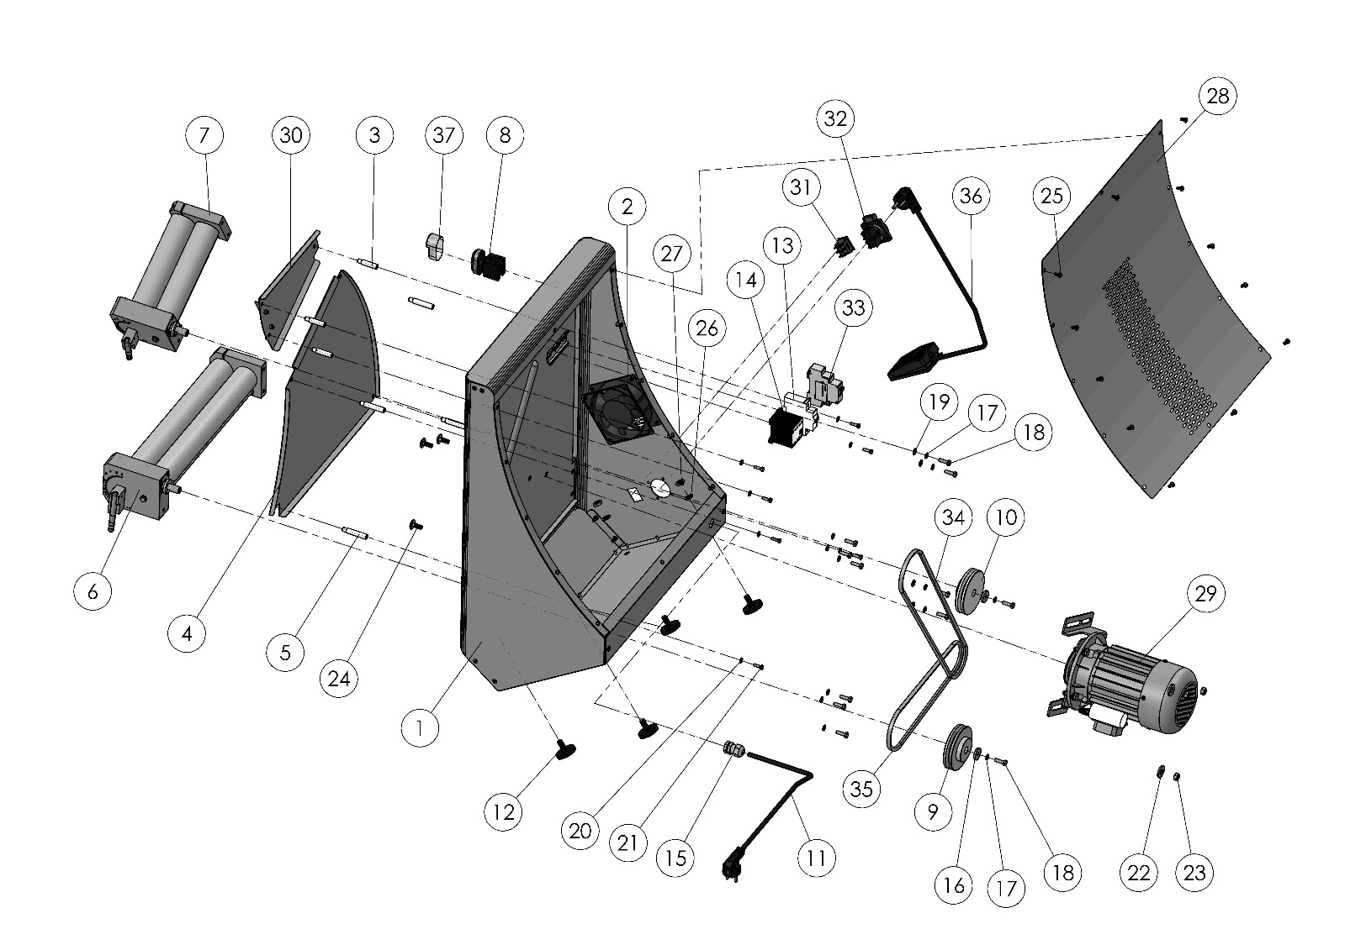
HX-40H / HX-40DH BODY
Optional

HX-40H HX-40DH

NOTE: Parts 31, 32, 33, 36 are optional on all models.

ITEM | SPARE PART NUMBER | DESCRIPTION OF THE SPARE PART | UNIT
1 | 00063M | BODY | 1
2 | 00059 | FAN | 1
3 | 00133 | TOP ROAD SHEET PIN (SHORT) | 3
4 | 00412 | MIDDLE ROAD SHEET | 1
5 | 00132 | MIDDLE ROAD SHEET PIN (LONG) | 4
6 | M0017 | BOTTOM ROLLER | 1
7 | M0016 | TOP ROLLER | 1
8 | 00365 | ON / OFF SWITCH | 1
9 | 00005 | PULLEY | 1
10 | 00085 | PULLEY | 1
11 | 00355 | ELECTRIC CABLE | 1
12 | 00354 | LEG | 4
13 | 00057 | FUSE | 1
14 | 00056 | CONTAKTOR | 1
15 | 00097 | RECORD | 1
16 | 00006 | WASHER | 2
17 | 00042 | WASHER | 12
18 | 00041 | BOLT | 12
19 | 00050 | WASHER | 4
20 | 00051 | WASHER | 7
21 | 00049 | BOLT | 7
22 | 01258 | WASHER | 3
23 | 01959 | NUT | 3
24 | 00476 | BOLT | 3
25 | 00046 | BOLT | 14
26 | 01960 | WASHER | 4
27 | 01965 | NUT | 4
28 | 00362M | BACK COVER | 1
29 | 00058M | ENGINE | 1
30 | 00082M | BOTTOM ROAD SHEET | 1
31 | 00369 | I0II SWITCH (OPTIONAL) | 1
32 | 00357 | SOCKET (OPTIONAL) | 1
33 | 00367 | CIRCUIT BREAKER (OPTIONAL) | 1
34 | 00428 | V BELT | 1
35 | 00424 | V BELT | 1
36 | 00034M | PEDAL (OPTIONAL) | 1
37 | 00620 | BUTTON CASE | 1
HX-40H/HX-40DH BODY SPARE PART LIST
HX-40DH: The Different Parts
ITEM | SPARE PART NUMBER | DESCRIPTION OF THE SPARE PART | UNIT
1 | 00079M | BODY | 1
4 | 00436 | MIDDLE ROAD SHEET | 1
30 | 000437 | TOP ROAD SHEET | 1
34 | 00439 | V BELT | 1
35 | 00422 | V BELT | 1

SECTION 6: ROLLER PROTECTION SHEET ASSEMBLY

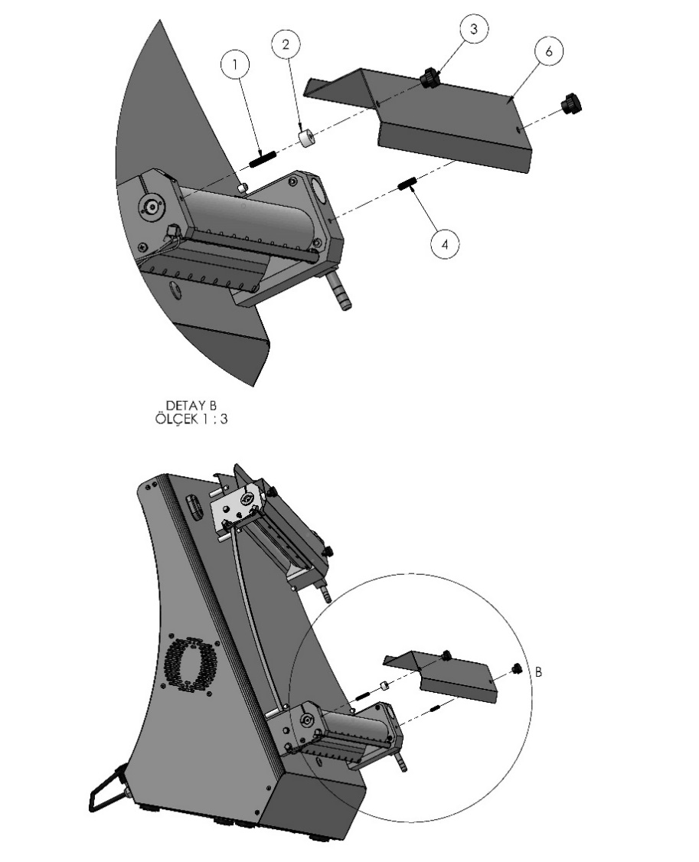

DETAIL B
SCALE 1: 3
DETAIL A
SCALE 1: 4

PART DESCRIPTION
1 | STAY BOLT (LEFT)
2 | GUARD SHEET THIMBLE
3 | BOARDING HANDLE
4 | STAY BOLT (RIGHT)
5 | GUARD SHEET (TOP ROLLER)
6 | GUARD SHEET (BOTTOM ROLLER)

SECTION 7: ELECTRICAL DIAGRAM
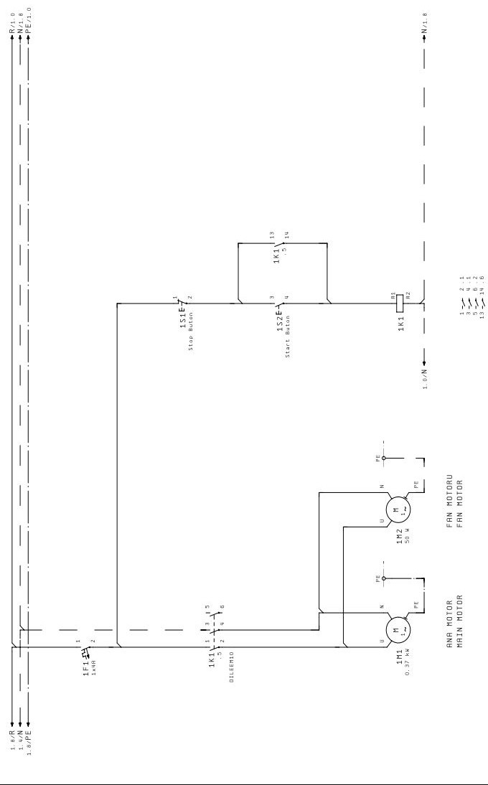
7.1 HX-30H/40H, HX- 30DH/40DH Electrical Diagram:

7.2 HX-30H/40H Pedal, HX-30DH/40DH Pedal Electrical Diagram:

